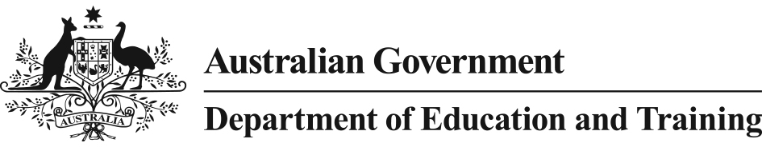

# VET Student Loans Act 2016

## Notice under Subsection 53(1) of *VET Student Loans Act 2016*

I, Maryann Quagliata, Branch Manager, VET Student Loans, Department of Education and Training (**Department**) am a delegate of the Secretary of the Department under subsection 114(1) of the *VET Student Loans Act 2016* (**Act**).

Under section 53(1) of the Act, the Secretary may by notice in writing, require an approved course provider to provide the Secretary with information or documents that relate to the provision of vocational education and training by the provider, or the provider’s compliance with the Act. The Secretary may specify the form and other requirements that the information or documents must be provided in.

I exercise the Secretary’s powers undersubsection 53(1) of the Act to issue this notice to all approved course providers approved under the Act, and:

1. Require approved course providers to provide me with data for the 2017 VET Student Loans Data Collection, in accordance with the requirements set out in the *2017 VET Data Requirements* which can be accessed at: <http://heimshelp.education.gov.au/sites/heimshelp/2017_data_requirements/2017vet/pages/vet-2017>
2. Specify that the form in which approved course providers must provide all data required by this Notice is as electronic data files which must be lodged by approved course providers via the following Department submission methods:

* the Higher Education Client Assistance Tool (HEPCAT);
* a web service channel; and
* the department web browser.

1. Require approved course providers to lodge a Statutory Declaration, executed by either the Chief Executive Officer or Chief Finance Officer, in the HELP IT System (HITS) at the time of reporting. The required Statutory Declaration is to be accessed in HITS.

Approved course providers are required to check for and comply with any changes which may, from time to time, be made to the data requirements. All changes to the requirements for the VET Student Loans Data Collection will be noted in the 2017 VET Student Loans Data Requirements.

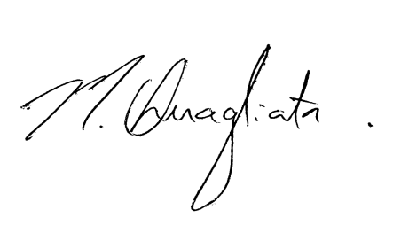

Maryann Quagliata

Branch Manager, VET Student Loans Branch, Department of Education and Training

23 January 2017