

# HIGHER EDUCATION SUPPORT ACT 2003

## Notice under subclause 24(1) of Schedule 1A of HESA

I, Maryann Quagliata, Branch Manager, VET Student Loans, Department of Education and Training, and a delegate of the Minister for Education and Training under subsection 238‑5(1)(b) of the Higher Education Support Act 2003 (HESA) for the purposes of subclause 24(1) of Schedule 1A to HESA:

1. Require you to give me data for the 2017 VET FEE‑HELP Data Collection. The requirements are set out in the *2017 VET Data Requirements* and *Change Control document* which can be accessed at: <http://heimshelp.education.gov.au/sites/heimshelp/2017_data_requirements/2017vet/pages/vet-2017>
2. Under subclause 24(1) of Schedule 1A to HESA, I approve the form in which you must give all the data required by this Notice to me as electronic data files which must be lodged by you via the following department submission methods:

* the Higher Education Client Assistance Tool (HEPCAT)
* a web service channel; and/or
* the department web browser.

1. Require you to lodge a Statutory Declaration, executed by either the Chief Executive Officer or Chief Finance Officer, in the HELP IT System (HITS) at the time of reporting. The required Statutory Declaration is to be accessed in HITS.

The reporting requirements are also available to download from: <http://heimshelp.education.gov.au/sites/heimshelp/resources/pages/min-notice-packages>.

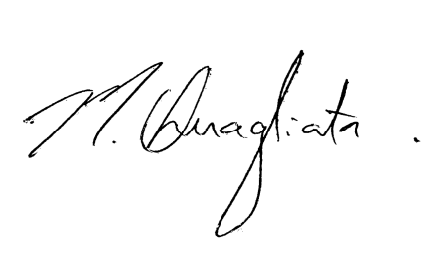You are required to check for any changes which may, from time to time, be made to the data requirements. All changes to the requirements for the VET FEE-HELP Data Collection will be noted in the 2017 VET FEE-HELP Data Requirements and Change Control document.

Maryann Quagliata

5 December 2016