

VET STUDENT LOANS ACT 2016

Notice under Subsection 53(1) of the VET Student Loans Act 2016
– 2026 VET Student Loans Data Collection (No.1)
I, Thomas Varendorff, Assistant Secretary, VET Student Loans Branch, Department of Employment and Workplace Relations (the department), delegate of the Secretary of the department under subsection 114(1) of the VET Student Loans Act 2016 (the Act) exercise the Secretary's powers under the Act as follows.

Under subsection 53(1) of the Act, the Secretary may by notice in writing, require an approved course provider to provide the Secretary with information or documents that relate to the provision of vocational education and training by the provider, or the provider's compliance with the Act. The Secretary may specify the form and other requirements that the information or documents must be provided in.

I exercise the powers under subsection 53(1) of the Act to issue this notice to all course providers approved under the Act and approve the form and requirements in which all 2026 data must be lodged. This notice replaces the previous ‘Notice under Subsection 53(1) of the Act – 2025 VET Student Loans Data Collection (No. 1)’ dated 8 July 2025 which ceases to apply as from the date of this notice.

From the date of this notice, the 2026 VET Student Loans data reporting requirements are:

- Tertiary Collection of Student Information (TCSI)
The 2026 Reporting Requirements webpage lists all data packets which are reportable in TCSI. The individual packet pages detail the scope and structure of each packet and the due dates for reporting.

Submission is via the following channels using the TCSI system:
- APIs (Application Programming Interface) for submission from the provider’s student management system to the Government; or
- file upload or web form submission via the TCSI Data Entry portal.

- Accuracy of Data
The information or documents reported by a provider must be accurate and only be in relation to genuine students (as defined in the VET Student Loan Rules 2016). The information must be reported by an executive officer as defined in the Act, or a person approved by an executive officer to report the information.

Advice on how to rectify incorrect information is provided in the Data Reporting Requirements for 2026 .

- Revising and adding data
Where a unit of study (data element 354) has previously been reported in a Unit enrolment packet (VET), and the reported HELP loan amount (data element E558) has previously been paid in part or in full, the previously reported HELP loan amount must not be subsequently edited to increase that HELP loan amount. The HELP loan amount may continue to be edited to decrease a previously reported and paid HELP loan amount.

Where an approved course provider is lawfully due an additional loan amount the provider may:

- where feasible and reasonable, add the increased amount to a subsequent unit of study. This may occur where subsequent units of study for the relevant course are available, and the increased amount is up to 10% of the indexed loan cap for the course; or
- where this is not feasible, the increased loan amount only may be reported, with the same census day, but with a unit code that begins with ‘INCR’ followed by so much of the original unit code, up to the 12-character field limit, as will identify the original related unit.

The total amount reported for a student for a loan cannot exceed the amount of the loan approved for that student for the relevant course.

A unit enrolment record should not be deleted and resubmitted to correct a loan amount. This action would cause indexation of the loan to be applied in a manner not consistent with the law.

- Compliance
Failure to comply with this notice may give rise to a civil penalty provision and a strict liability offence (both 60 penalty units – per subsections 53(4) and (5) of the Act). A person is also liable to a civil penalty of 240 penalty units if the person provides information or a document that is false or misleading or omits any matter or thing without which the information or document is misleading (section 106 of the Act).
- Further information and contacts
Further information on submission methods are available at tcsisupport.gov.au or by contacting TCSIsupport@education.gov.au
Approved course providers are required to check for and comply with any changes which may, from time to time, be made to the VET Student Loans data reporting requirements. All changes to the requirements for the VET Student Loans Data Collection will be noted in the 2026 Reporting Requirements Change Control document.

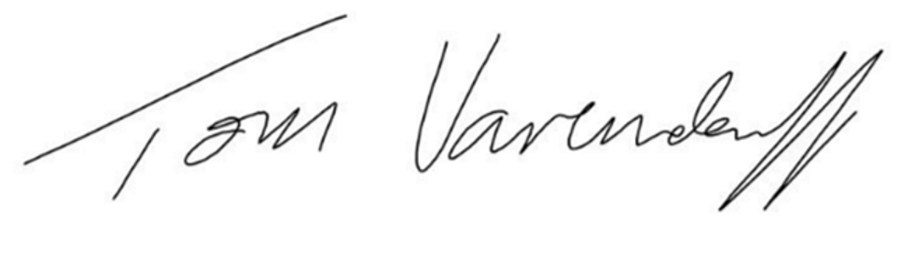
Thomas Varendorff
Assistant Secretary
VET Student Loans Branch

11 December 2025

