

HIGHER EDUCATION SUPPORT ACT 2003

Notice under subsection 19-70(1)

I, Nicholas Post, Assistant Secretary, Higher Education Analytic and Data Strategy Branch, Department of Education, delegate of the Minister for Education under paragraph 238-5(1)(b) of the Higher Education Support Act 2003 (HESA) for the purposes of subsection 19-70(2) of HESA:

Approve the form in which all 2026 data must be lodged. This is via the following submission channels:
- APIs (Application Programming Interface) for system-to-system submission; or
- File upload to the TCSI Data Entry portal.

The documents for these submission methods are available at the tcsisupport.gov.au site or by contacting TCSI Support at tcsisupport@education.gov.au.

You are required to check for any changes that may, from time to time, be made to the data requirements. All changes to the requirements for the Higher Education Data Collection will be noted in the 2026 Higher Education Data Requirements and Change Control document.

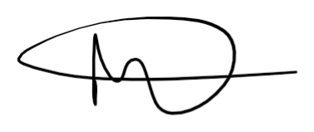

Nick Post
Assistant Secretary
Higher Education Analytic and Data System Branch
Australian Government Department of Education

5 November 2025

