

# **Expected Trends Dashboard User Guide**

Contents

1. Overview 3

2. Accessing the Dashboard 4

3. Interpreting the Dashboard Data 4

4. Equity Variables, Geospatial Insights and Student Geospatial Insights 5

5. Using the Maps 7

6. Primary vs. All Campus Locations for Headcounts 8

7. Year to Date 8

8. Quality Indicators Section 9

9. Live and Verified Definitions 10

10. Reporting Issues 10

### Overview

The Expected Trends Provider Dashboard is designed to provide insights into expected trends for higher education providers. This guide will help users understand how to navigate and utilise the dashboard effectively, as well as the rules for the elements included in the report.

**Purpose and Importance**

The Expected Trends Provider Dashboard is crucial for assessing the risks associated with higher education providers’ enrolment targets. It will help providers identify areas where they may have reporting gaps or data quality issues, assisting them in tracking ahead of the annual verification process.

**Key Features**

* **Insights into Predicted Enrolment Targets and Actual Trends**: The dashboard will provide insights into predicted enrolment targets and actual trends, which are essential for informed decision-making by providers. It will present current year data and high-impact targets, enabling proactive monitoring of student enrolments and Equivalent Full-Time Student Load (EFTSL).
* **Live and Verified Data**: The dashboard includes both live data, updated nightly from the TCSI database, and verified data at specific points in time. This allows for a current view of student activity and ensures data accuracy.
* **Visualisations and Data Export**: The dashboard presents clear and efficient visualisations of current and previous year data, with data table drill-through and export functionality. This helps providers to easily access and analyse the data.

### Accessing the Dashboard

1. **TCSI Analytics Portal**: The dashboard is available through the TCSI Analytics Portal. External users will need a [PRODA account](https://www.tcsisupport.gov.au/support/proda) to access the portal.
2. **Navigate to the Dashboard**: Locate the Expected Trends Provider Dashboard within the Dashboard section of the Interface.

### Interpreting the Dashboard Data

The Expected Trends Dashboard provides a comprehensive view of various metrics and trends. Here are some key points to help you interpret the data:

1. **Student Numbers (Headcount)**: This section displays the total number of students enrolled. The data is calculated using the Major Course. You can view the data by different categories such as year, course level, and broad field of education. This helps in understanding the overall student population and its distribution across different segments.



1. **Student Load (EFTSL)**: Equivalent Full-Time Student Load (EFTSL) data shows the total study load of students. This metric is crucial for understanding the workload and capacity of educational institutions. It can be broken down by discipline, course level, and year to provide detailed insights.
2. **Visualisations**: The dashboard includes various **visualisations** such as bar charts and scatter plots. Bar charts are suitable for displaying a small number of comparative items, including values over time. Scatter plots show an association between two variables, displaying values for two variables for a set of data as a collection of points.

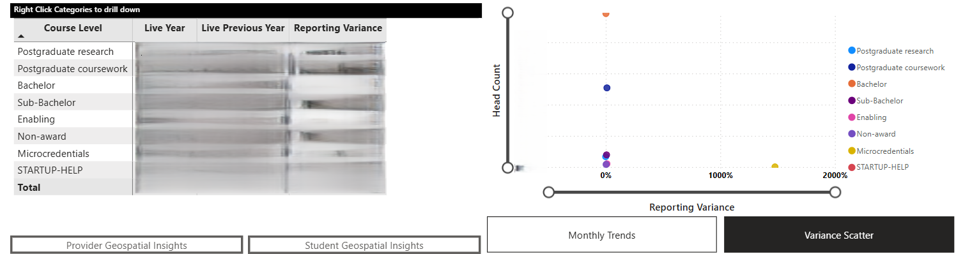

1. **Time Series Data**: The dashboard provides time series data, allowing you to track changes and trends over time. This is useful for identifying long-term patterns and making data-driven decisions.

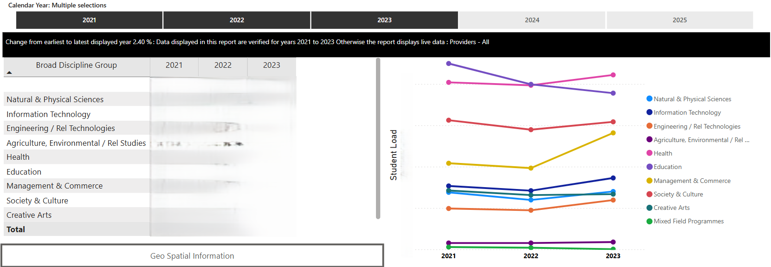

### Equity Variables, Geospatial Insights and Student Geospatial Insights

1. **Equity Variables**:
   * **First Nations**: Indicates whether a student identifies as a First Nations student.
   * **Disability Status**: Indicates whether a student has a disability.
   * **Students from a Non-English Speaking Background**: Indicates whether a student comes from a non-English speaking background.
   * **Women in Non-Traditional Areas**: Indicates whether a student is a woman studying in a non-traditional area.
   * **Regional/Remote Status**: Indicates whether a student is from a regional or remote area.
   * **Total Domestic Onshore Students**: Indicates the total number of domestic onshore students.

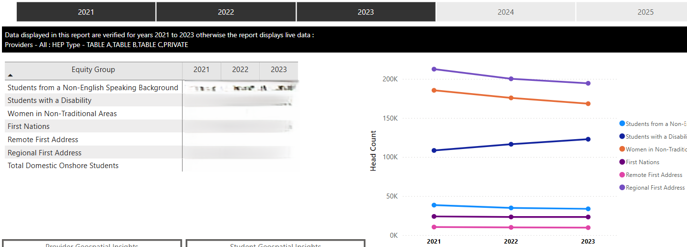

1. **Geo Spatial Insights**:
   * **Provider Geospatial Insights**: Indicates the geographical location of the campus.

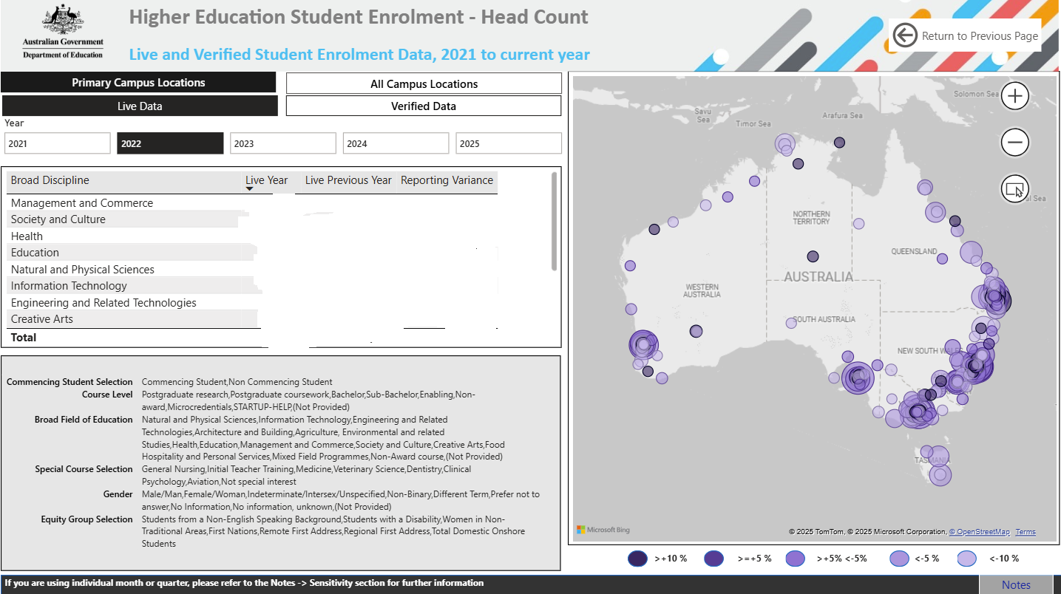

* Student Geospatial Insights: Indicates the location of students’ country of birth, first residential address, residential address and student term residence address.

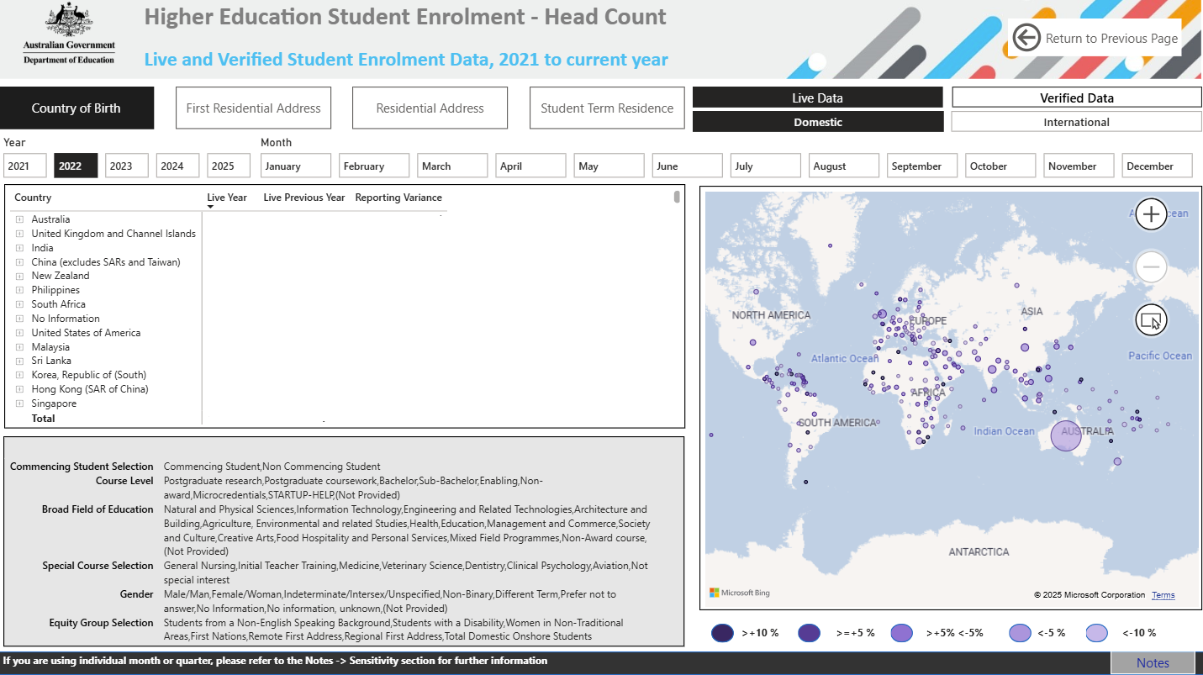

### Using the Maps

The maps in the Expected Trends Provider Dashboard provide a visual representation of various data points related to student enrolment/load and trends. Here’s how you can effectively use these maps:

To access the maps, navigate to the Geospatial insights sections within the Expected Trends Provider Dashboard. This section will display the geographical indicator and data points.

For an example, the maps in provider geospatial insights page include the E477 Delivery Location as the primary geographical indicator. This indicator helps in understanding the distribution of students across different regions.

You can interact with the maps by zooming in and out and clicking on specific regions to view detailed information. The maps are designed to be user-friendly and provide a comprehensive view of the data.

Use the filters available on the dashboard to narrow down the data displayed on the maps. You can filter by various criteria such as commencing status, citizenship, course level, and broad field of education to get a more focused view of the data.

Each data point on the map represents a specific metric related to student enrolment/load. For example, a data point might represent the number of students from a particular region or the distribution of students across different campuses.

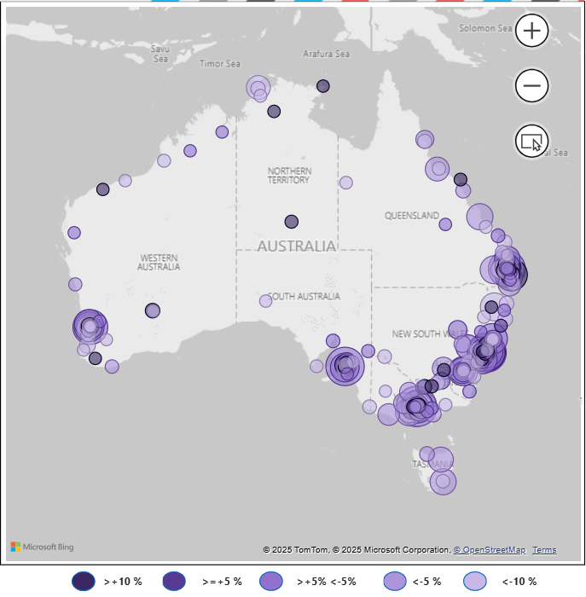

### Primary vs. All Campus Locations for Headcounts

When interpreting headcount data, it's important to understand the difference between Primary and All Campus locations:

* **Primary Campus Location**: This refers to the main campus where a student is primarily enrolled. Headcounts based on the primary campus location will count each student only once, based on their main campus of enrolment.
* **All Campus Locations**: This includes all campuses where a student is enrolled. Headcounts based on all campus locations may count a student multiple times if they are enrolled in courses at multiple campuses. This approach provides a more comprehensive view of student distribution across all campuses but may result in higher total counts due to multiple enrolments. (Insert snip)

### Year to Date

The Year to Date section of the Expected Trends Provider Dashboard represents the period from the start of the year to a later date of choice within that same year and compared to the same period for the previous year.

To access the Year to Date, navigate to the "Year to Date" section within the Expected Trends Provider Dashboard. This section will display various metrics related to Year to Date live and verified data.

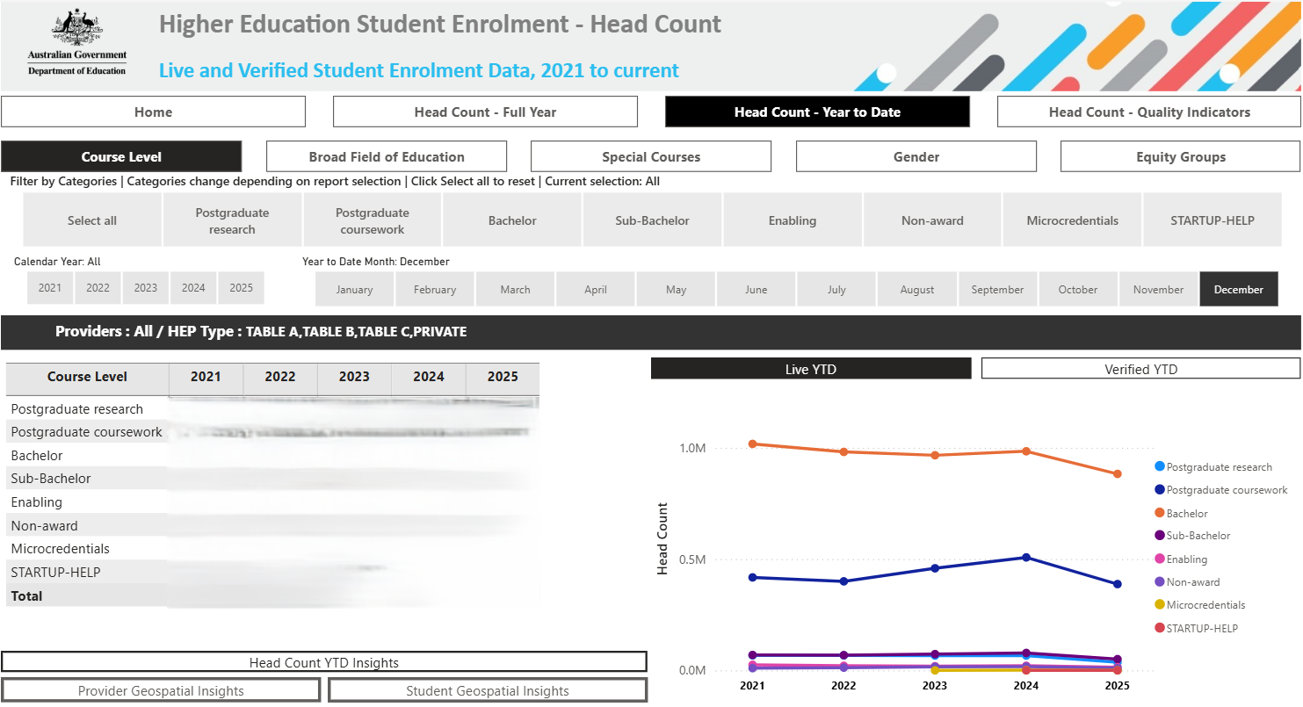

YTD Insights shows live monthly data with the comparison of the previous year/month data. Select one year at a time from the filter pane to view data correctly. Other filters enable to select data by month, broad citizenship and commencing status.

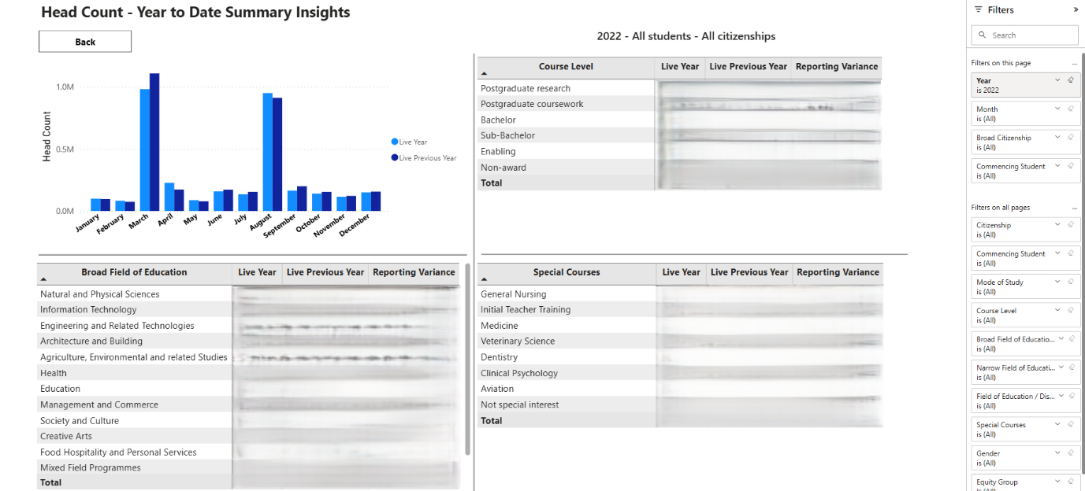

### Quality Indicators Section

The Quality Indicators Section in the Expected Trends Provider Dashboard provides insights into various aspects of live and verified student data quality and reporting. These indicators help in understanding the accuracy and completeness of the data submitted by providers.

The Quality Indicators include metrics such as Course Level, Broad Field of Education/Broad Discipline Groups, Special Courses, Gender and Equity groups. Use the tabs available on the dashboard to select yearly, quarterly or monthly data.

Filters available on the dashboard enable you to narrow down the data displayed for each Quality indicator. You can filter by various criteria such as citizenship, course level, and gender to get a more focused view of the data.

The Quality Indicators section allows you to analyse trends over time by displaying historical data. This can help in identifying patterns and making data-driven decisions.

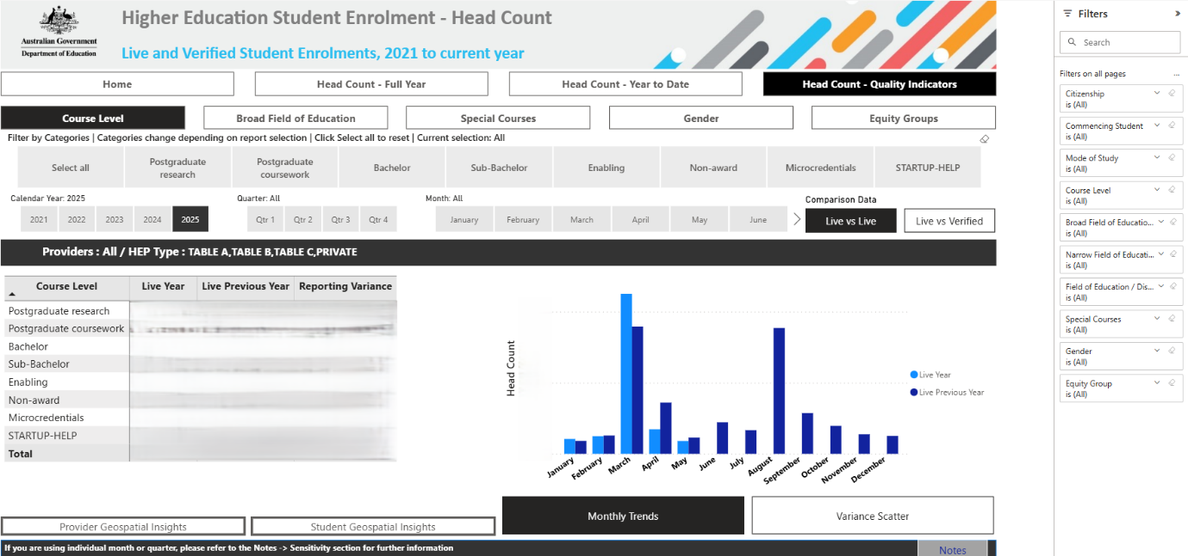

### Live and Verified Definitions

The dashboard provides both live and verified data measures:

* **Live Data**: This refers to the most current data available, which is continuously updated to reflect real-time changes. Live data provides an up-to-date snapshot of the metrics being tracked. For live data, enrolments with future census dates are excluded from this report.
* **Verified Data**: This refers to data that has been reviewed and confirmed for accuracy. Verified data is typically used for official reporting and analysis, as it has undergone a validation process to ensure its reliability.

By understanding the difference between live and verified data, you can make more informed decisions based on the most accurate and current information available.

### Reporting Issues

1. **Identify Discrepancies**: If you encounter any issues or discrepancies in the data, report them to TCSI.renewal@education.gov.au.
2. **Provide Details**: Include specific details about the issue to help with troubleshooting.