

FTP user guide for TCSI Data Extracts

To access and download your data files from the department’s Web Transfer Client system, please follow the steps below:

**If you are accessing this service for the first time**

* Click on **View folder** from the invitation link received via email. This will take you to the Web Transfer Client page. (Please check your junk folder if you have not received this email.)

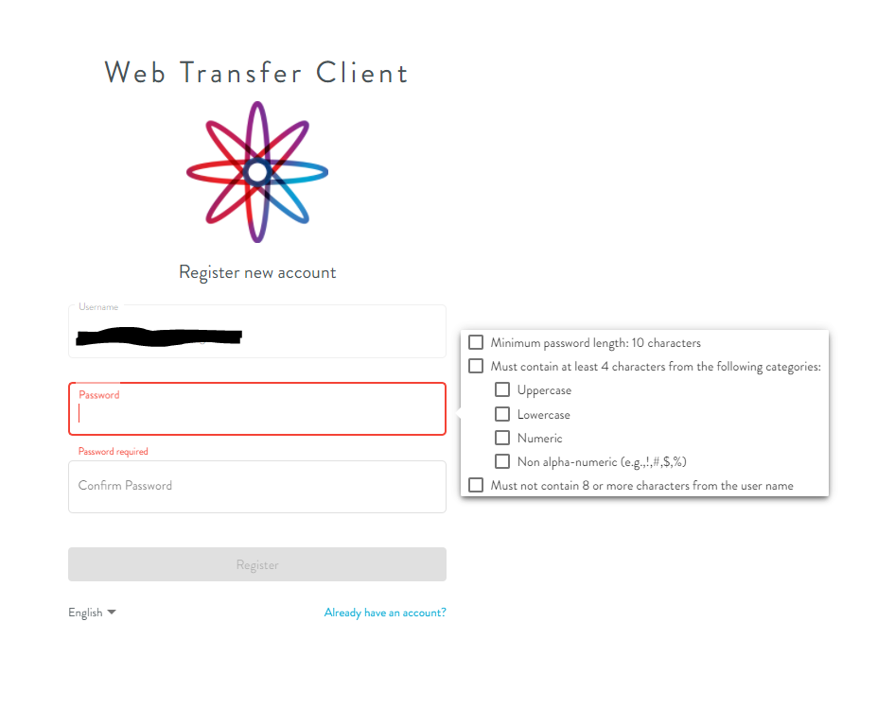

* Your username will be the email address to which the invitation link was emailed, and you will need to create a password following the requirements on the screen (10 characters with at least 1 uppercase, 1 lowercase, 1 number and containing 1 special character i.e. !@#$% ).
* Note that usernames and passwords are both case sensitive.
* Once you click **Register** you will be sent an email to complete your registration. (Please check your junk folder if you have not received this email.)

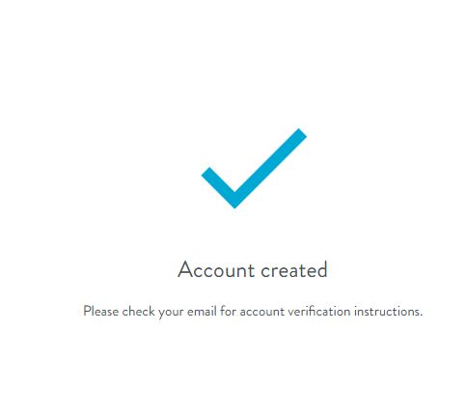

* Click on **Verify account** in the second email received.
* Your account will be verified and you will be taken to your data extract folder.
* To download your files, click on the folder and open the zip file.  Multiple files can be downloaded at once by ticking the box to select all of the files, or you can individually tick each file.

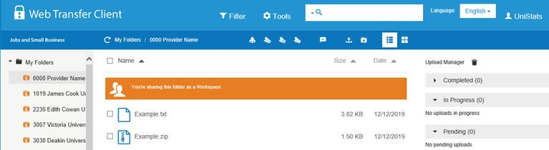

* Once you have selected the files required, click on the following button cid:image007.png@01D5B0F3.086CFEC0to download and save.

**If you have accessed this service previously**

* Go to <https://ftp.jobs.gov.au> and log into your account, remembering that your username is the email address you used to set up your account.
* Note that usernames and passwords are both case sensitive.

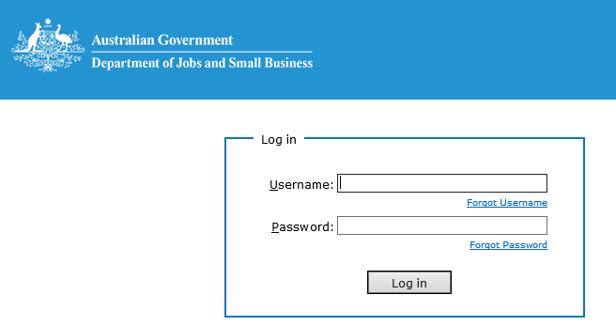

* If you do not remember your password, please use the **Forgot Password** link to reset it.

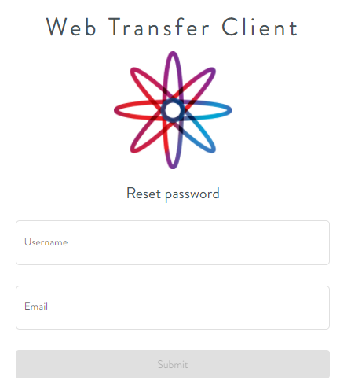

* Enter your username and email (both fields will require the same email address) and click submit.

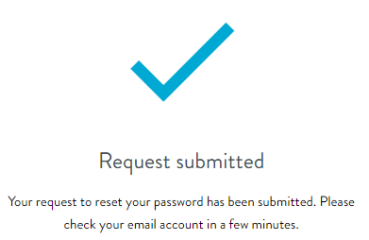

* You will then receive an email with a link to reset your password.
* If you have any issues please contact [TCSISupport@education.gov.au](mailto:TCSISupport@education.gov.au) for support.

# How to import your CSV file into Excel

To import your CSV files into Excel you will need to use the text import wizard in Excel and follow the steps below:

Note that these instructions are for Microsoft Excel 2016

* From the **Data Tab**, click **From Text/CSV** (found in the ‘Get & Transform Data’ group)
* double click the file to be imported
* the **Text Import Wizard** dialog will open
* choose **Delimited**
* to retain headings, check the box **My data has headers**, click next
* select the **Comma** **Delimiters (and deselect Tab Delimiters)**, click next
* Select **Text** for all Column data format, click **finish**
* Import data into **Existing worksheet = $A$1**
* **Click OK** to complete