

Provider Data Verification User Guide

A guide to Data Verification using TCSI Analytics

Contents

1. Overview 2

2. Purpose 2

3. Timing 3

4. Process overview 3

5. Access to TCSI Analytics 5

6. Accessing the verification reports 5

7. Verification process 13

7.1 Activated 13

7.2 Verifying 15

7.3 Verified 15

7.4 Refresh 17

7.5 Sign Off 19

8. Report slicer and Data Drill-through 22

8.1 Report slicers 22

8.2 Data Drill-through 23

9. Exporting reports 24

10. Percentage change in data 25

Appendix 26

Status and actions 26

## Overview

TCSI Analytics Portal allows Higher education providers to view their data reported to TCSI and provides a self-service interface to enable providers to verify the accuracy of this data. The Provider Data Verification (PDV) interface is based on the previous HEIMS Online process.

TCSI Analytics Portal enables providers to directly access:

* Unit Records - real-time data presented in line-by-line format
* Notifications - list of notifications created from data sent to TCSI. (To be included in a future release)
* Live data Reports - use real-time data and are generally presented in a summarised format.
* Verification Reports - generated from unverified data sent to TCSI database.
* Verified Reports - generated from verified data after a collection has been finalised.

The PDV process allows providers to meet their data verification obligations legislated under the [*Higher Education Support ACT 2003* (HESA)](https://www.legislation.gov.au/Series/C2004A01234). Verification is the final stage for providers to certify that the data reported to TCSI throughout the year is complete and accurate.

While a comprehensive set of Real Time and Scheduled Validations are undertaken to support the reporting of quality data, these validations cannot identify every possible data integrity issue. Verification confirms that student debts accurately reflect the amount of assistance received, ensures provider payments are correctly reconciled and the data included in the department's publications are accurate.

Data received in TCSI's transactional database is displayed in a set of verification reports grouped into Collections e.g., Student. When verification has been activated by the department and the reports become available the reports will continue to be refreshed nightly with latest data received until the provider indicates they are ready to start the verification process in TCSI Analytics. The dataset taken before starting verification is known as the unverified data snapshot.

Once all reports within a Collection have been checked and confirmed accurate, the Collection is verified, and the reports can then be signed off by the provider. Signing off will create the providers verified dataset.

## Purpose

The purpose of this document is to assist higher education providers to formally verify their data using the verification interface and reports provided in the TCSI Analytics Portal. The verification process formally confirms the accuracy of data sent to TCSI's transactional database through APIs or via TCSI Data Entry Portal.

The verification reports in TCSI Analytics displays static data, i.e., data which has been fixed at a particular point in time for funding, statistics, and publications purposes.

The list of reports that must be verified and details on how to interpret each of the reports can be found on the TCSI Support website from the TCSI Analytics webpage [Verification Reports](https://www.tcsisupport.gov.au/view-data/TCSI-Analytics).

## Timing

Provides are required to confirm the accuracy of their data within the required timeframes each year. With the introduction of TCSI the verification timeframes have changed. The verification of student data has moved from twice a year occurrence in September and April to an annual process.

For information about the reporting requirements, timeframes and how to make corrections can be accessed from the overview pages for each data collection:

* [Higher Education Student Data Collection](https://www.tcsisupport.gov.au/reporting/hestudent" \o "TCSI Support - Higher Education Student Data Collection)
* [Higher Education Staff Data Collection](https://www.tcsisupport.gov.au/reporting/hestaff" \o "TCSI Support - Higher Education Staff Data Collection)
* [University Applications and Offers Data Collection](https://www.tcsisupport.gov.au/reporting/university) not included in this formal verification process

## Process overview

Details of the reports to be verified for each provider can be accessed from [TCSI Analytics webpage](https://www.tcsisupport.gov.au/view-data/TCSI-Analytics) on TCSI Support under the Verification Reports section.

The verification process will generate all reports for the Student Collection regardless of the provider type. For Non-University (private) Higher Education Providers some reports will not contain data as your organisation does not provide this data type to TCSI, the reports can be ignored. Universities (Table A and B Higher Education Providers) will need to assess and signed off on all reports for the Student Collection to complete verification.

As providers progress through the verification process, the status of their reports will move from not verified to verified, as listed in Table 6.

Table 1 – Report status

| **Report Status** | **Purpose** |
| --- | --- |
| **Not Verified** | This status is displayed when the provider is yet to commence verification and the verify button has not been selected. |
| **Verifying** | This status is displayed when the provider has started to verify the reports in a collection |
| **Verified** | This status is displayed when the Verify button has been selected for a report. When all reports in a collection have been verified the provider can sign off the collection. |

Figure 1 Verification process overview

## Access to TCSI Analytics

To access TCSI Analytics click on the TCSI Access button in the banner of the [TCSI Support website](https://www.tcsisupport.gov.au), (Figure 2).

It is recommended to use one of the following web browsers when accessing TCSI services - Google Chrome, Microsoft Edge Chromium or Firefox.

Figure 2 – TCSI Support Website home pageA picture containing text, software, multimedia software, font

Description automatically generated

Providers will need to ensure that their staff and organisation are set up in PRODA to access TCSI Analytics.

A staff member can access the 'Verification' screen in TCSI Analytics if the user is a member of an organisation registered with PRODA with access to the TCSI service and has at least one of the TCSI attributes for verification.

* TCSI Analytics – Verify (Provides the ability to verify a dataset)
* TCSI Analytics – Signoff (Provides the ability to sign-off a verified dataset)

When a staff member accesses the verification screen, only the information that relates to the organisation that they are a member of is visible.

A step-by-step guide for setting up staff access is available at the [Access (PRODA)](https://www.tcsisupport.gov.au/support/proda) page on the TCSI Support website.

## Accessing the verification reports

1. Click on the Go to TCSI Analytics button, (Figure 3).

Figure 3 – TCSI Analytics home page

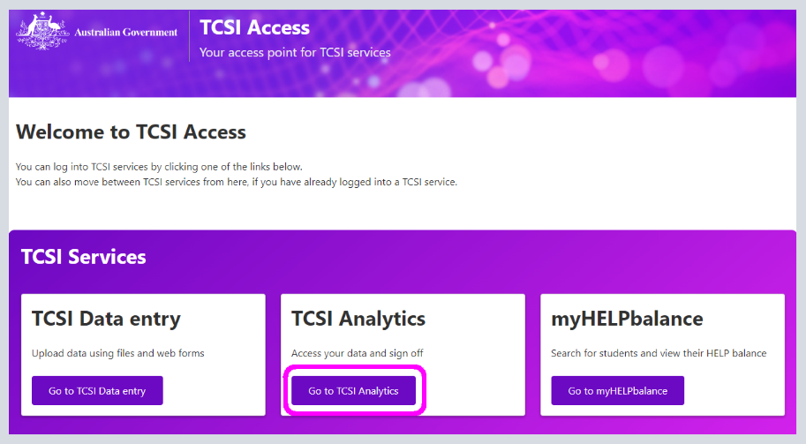

1. Click on the **Sign in** button on the Provider tile to access TCSI services as a provider, (Figure 4).

Figure 4 – TCSI Analytics home page – sign into access TCSI Services

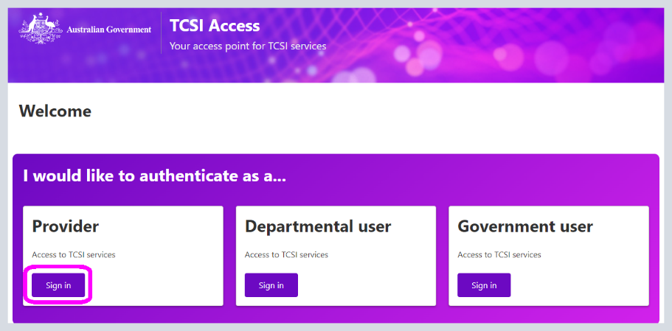

1. Login using your PRODA account username and password, (Figure 5).

Figure 5 – Enter PRODA credentials

1. Enter the verification code sent to the email address linked to your PRODA account, (Figure 6).

Figure 6 – Verification code for PRODA access

1. Select the organisation that your PRODA account is linked to.
2. The terms and conditions that apply to TCSI must be reviewed and confirmed by ticking the check box to provide your confirmation and agreement, once checked click on **Continue**   
   (Figure 7).

Figure 7 - Terms and Conditions to access TCSI Analytics Portal

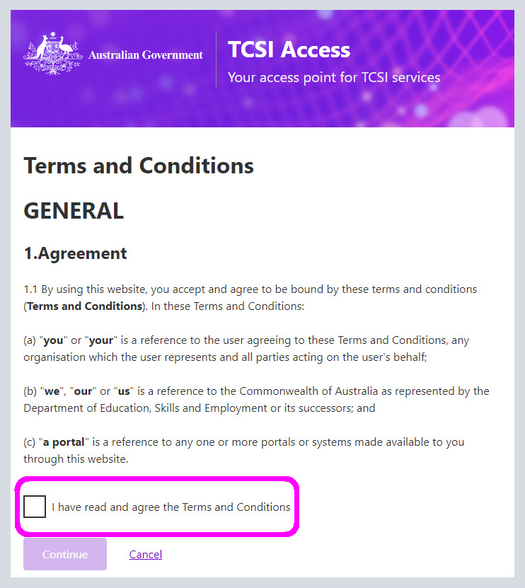

1. When logged in successfully the TCSI Analytics welcome screen will appear and your organisations reports - Unit records, Notifications and Live reports will be listed under the Reports tab including Verification and Verified reports for a collection that has been activated, (Figure 8).

Figure 8 – Menu options for TCSI Analytics welcome screen

1. From the welcome screen you can select from the options provided in the drop-down menus, as listed in Table 2.

Table 2 – Welcome screen options

| Verification | Commences |
| --- | --- |
| **Data type** | Select the data type that applies to the information that your organisation sends to TCSI i.e., **HEP** for Higher Education or **VET** for VET Student Loans. |
| **Report type** | The report types available for selection: **Live Data Reports** – these reports use real-time data and are generally presented in a summarised format. **Unit Records** – are real-time data presented in line-by-line format. **Notification Reports** – these reports list notifications received by the provider from data sent to TCSI.  **Verification Reports** – are generated from unverified data sent to TCSI database. **Verified Reports** – are generated from verified data after a collection has been finalised by the department. |
| **Report** | To be used to select one individual report displayed in the list. |
| **Clear** | Use this button to clear the filters and re-display the full set of reports. |

1. When a Collection has been activated to view the Verification Reports click on the Verification tab and select the relevant Collection as shown in (Figure 9).

Figure 9 – Verification report options available from TCSI Analytics

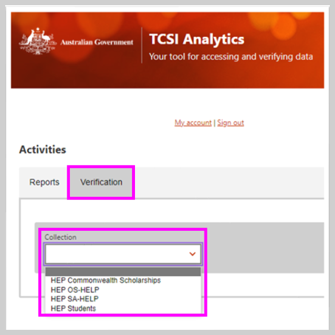

1. The dropdown list will display the available Collections when the department has opened a Collection, all relevant reports for the Collection will be displayed, (Figure 10).

**Figure 10 – Reports for Student Collection**

1. The components displayed on the verification screen for a collection, and their purpose are explained in Table 3 (Figure 11).

Figure 11 – Collection components displayed on the verification screen

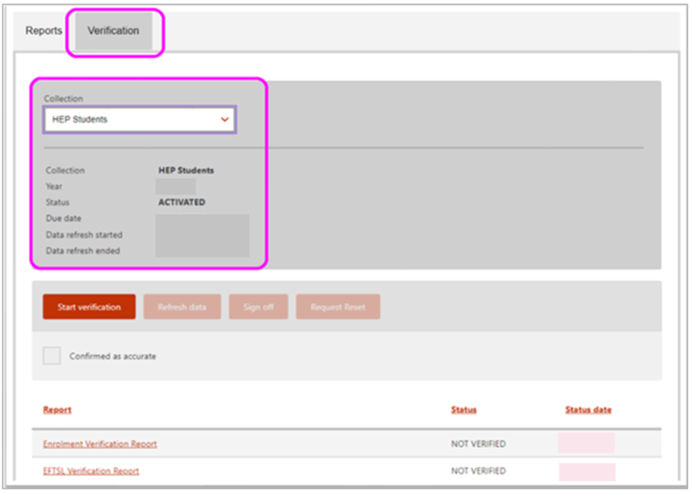

Table 3 – Verification screen components

| Components | Purpose |
| --- | --- |
| Name of the Collection | Displays the name of the collection selected. |
| Verification Year | Displays the applicable reporting year. |
| Status | Displays the latest status for the collection selected. |
| Due date | Displays the deadline to signing off on the collection. |
| Data refresh started date | Displays the latest refresh request. |
| Data refresh end date | Displays the latest refresh completed. |
| Start Verification button | To start verifying the collection and create the data snapshot. |
| Refresh data button | To request a refresh of data for a collection. |
| Sign off button | To sign off on a collection once the data is confirmed accurate. |
| Request reset button | To request a reset of the signed off status for a collection. |
| Confirmed as accurate check box | To certify that the data is accurate for the collection. |

1. The list of reports provided for a Collection can be sorted into ascending or descending order by clicking on the arrow beside the table headings of Reports, Status and Status date, (Figure 12).

Figure 12 – Sorting reports into ascending or descending order

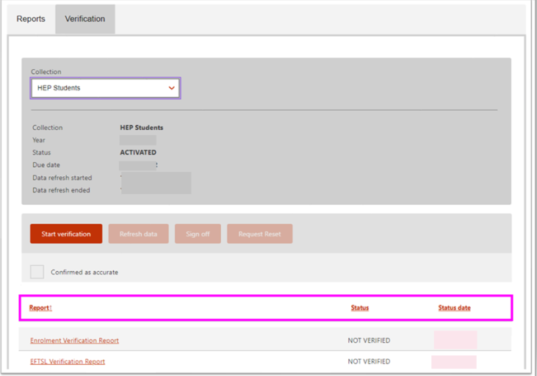

1. The Student Collection has a range of reports based on the data providers have sent to TCSI. Other Collections may only have one report, such as SA-HELP and OS-HELP. To verify a Collection, click on the first report to be assessed and progress until all reports for the collection have been checked and verified.
2. Details are provided at the top of each report to confirm the verification status, when the data was last refreshed and a Fullscreen option, (Figure 13) and Table 4 – Report components.

Figure 13 – Verification reports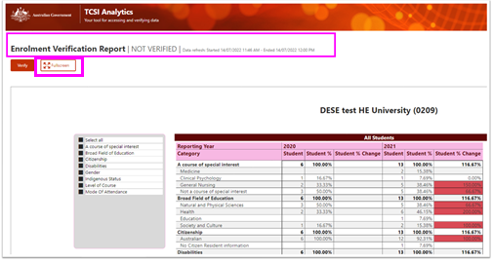

Table 4 – Report components

| **Components** | **Purpose** |
| --- | --- |
| **Title** | Displays the name of the selected report. |
| **Status** | Two statuses are provided to match the current state, either Not verified or Verified. |
| **Last data refresh date** | Two dates are provided, the latest refresh request and latest completed refresh dates. |
| **Verify button** | Clicking this button will update the status to VERFIED. |
| **Fullscreen button** | Displays the report in full screen view, ESC key will return to the report view screen. |

1. The Verify button enables the user to update the status to VERFIED when satisfied that the data in the report has been checked and confirmed accurate, (Figure 14).

Figure 14 – Reports - Verify button

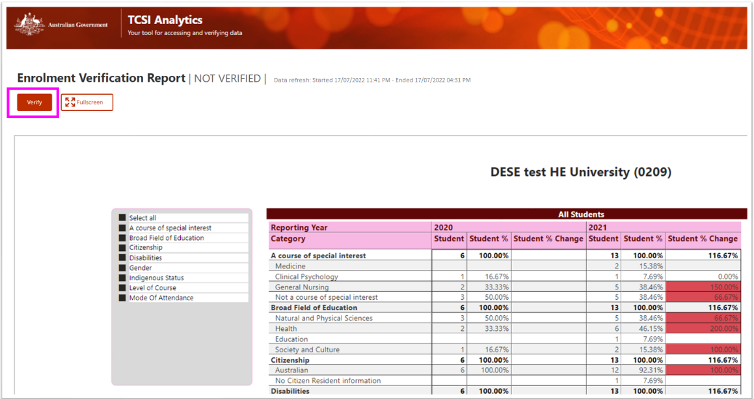

## Verification process

### 7.1 Activated

1. When a collection has been activated by the department the relevant reports of unverified data are generated and these reports will continue to be refreshed nightly until the provider selects ***Start verification***, (Figure 15).

Figure 15 – Verification activated

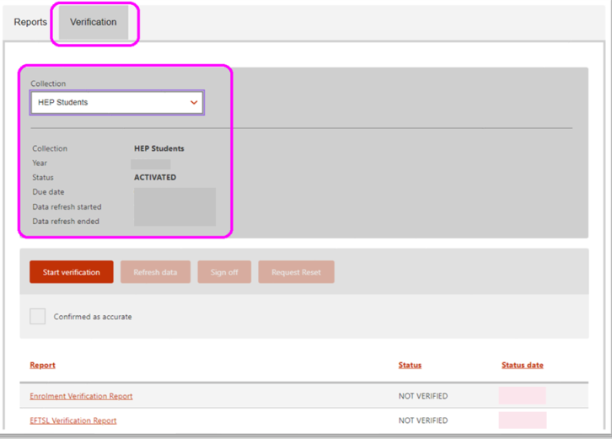

1. To commence verification, select ***Start verification***, (Figure 16) This stops the nightly refresh process; a snapshot of unverified data is taken on the day the provider starts verification. The status for the Collection moves from ***Activated*** to ***Verifying***, (Figure 17).
2. When ***Start Verification*** has been selected the department knows that you have commenced verifying and the data in your reports will remain static at this point in time, even though the provider may update data.

Figure 16 – Start verification

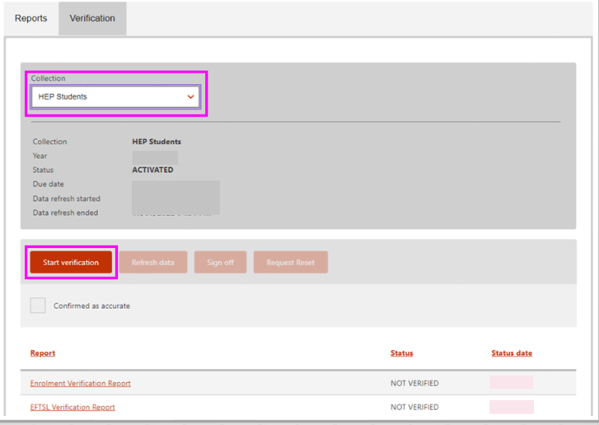

### 7.2 Verifying

Figure 17 – Verification started – Status updated to Verifying

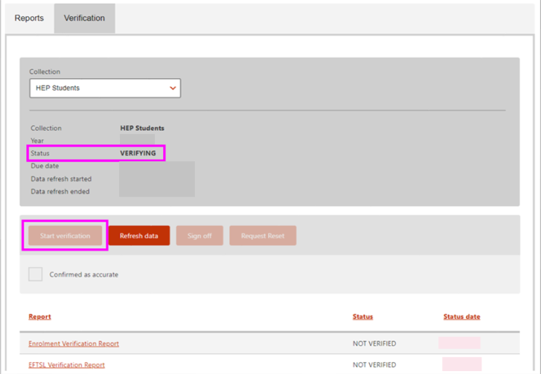

1. To start checking the reports for a collection, click on the report name from the list to view the report, (Figure 18).

Figure 18 – Verification started – Accessing report

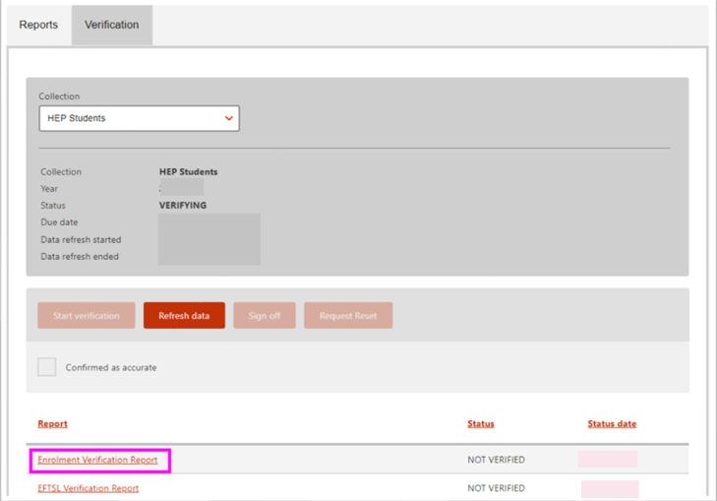

### 7.3 Verified

1. When a report has been checked and confirmed to be accurate the verify button is selected, (Figure 19).

Figure 19 – Verification report – NOT VERIFIED status

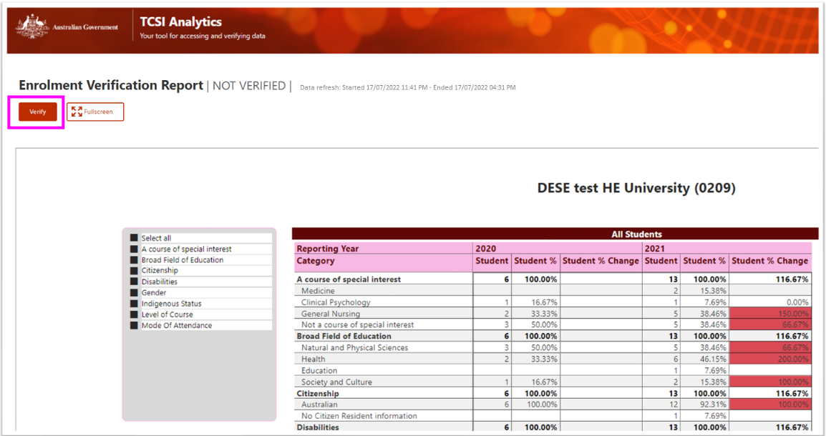

1. When VERIFY has been selected the Verify button will be disabled as the report status has been updated to VERIFIED, (Figure 20).

Figure 20 – Verification report – VERIFIED status

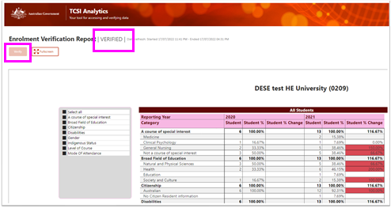

1. The status of the collection is then updated on the verification screen to VERIFYING and the status of the report is VERIFIED, (Figure 21).

Figure 21 - Verification screen – Collection status VERIFYING and Report status VERIFIED

### 7.4 Refresh

1. If you find an inaccuracy in one of your reports, you can update the data in TCSI and when satisfied that the relevant data is correct, you can select Refresh data to refresh your reports to include the updates. All reports linked to the collection will be refreshed, (Figure 22).   
     
   It is advisable to only select Refresh data if corrections are made or additional data has been provided after verification commenced.

**Figure 22 - Refresh data to include updates**

1. The status of Refreshing will appear when you select Refresh data. The refreshing of reports is a nightly process, whilst the refresh is in progress your reports will no longer be available for the applicable collection until the overnight refresh is completed, (Figure 23).

Figure 23 - Status updated to Refreshing

1. After the refresh is completed, the next day the status will revert to ***Activated***, and the Collection is returned to the ***Start verification***, your reports are available for re-checking. The initial snapshot taken when verification first started is updated, this latest snapshot will remain static even when further updates are made during verification, (Figure 24).

Figure 24 – Status – Reverted back to Activated

### 7.5 Sign Off

1. The last step is to sign off. Once you are confident that your reports are accurate and you have selected to verify all reports within the collection, the status will update to ***VERIFIED,*** (Figure 25).
2. The confirmed as accurate check box and sign off button will be disabled if all reports in the collection have not been verified, the status is Not Verified. (Figure 25).

Figure 25 – Report status – Not VerifiedA screenshot of a computer

Description automatically generated with medium confidence

1. To ***Sign off*** will require ticking the checkbox indicating that your data is confirmed to be accurate and then selecting ***Sign off.*** The collection will then be updated to ***SIGNED OFF***, (Figure 26).

Figure 26 – Sign off - Collection

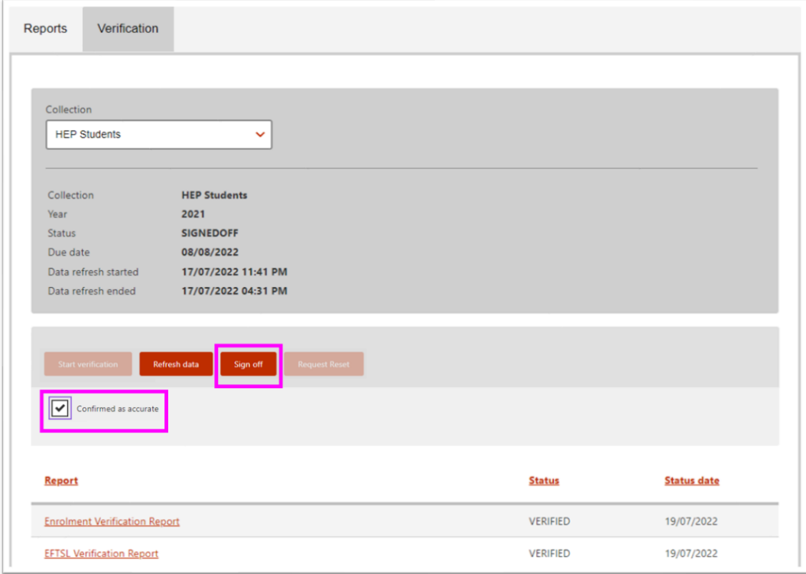

1. Signing off on your verified data stops any further requests for a refresh and the data in your reports will remain unchanged unless a ***Reset Request*** is submitted and accepted. A snapshot of your **Verified** data is taken and stored in the TCSI database. This snapshot is an aggregation of data signed off by each provider in their individual reports. After signing off only the ***Request Reset*** button is enabled, (Figure 27).

Figure 27 – Collection signed off

1. If you realise that your data is not accurate after ***Signed off***, you can submit a request to have the collection Reset, (Figure 27).
2. The department may accept or reject the request. When a Request Reset has been submitted all buttons are disabled, no further actions can be performed until the request has been processed. (Figure 28).

Figure 28 - Request Reset approved

1. If accepted, the status of the collection will be reset to ***Verified*** and you will need to recommence checking your reports. This may require refreshing your data to include latest updates. (Figure 29).

Figure 29 - Collection status – Verified

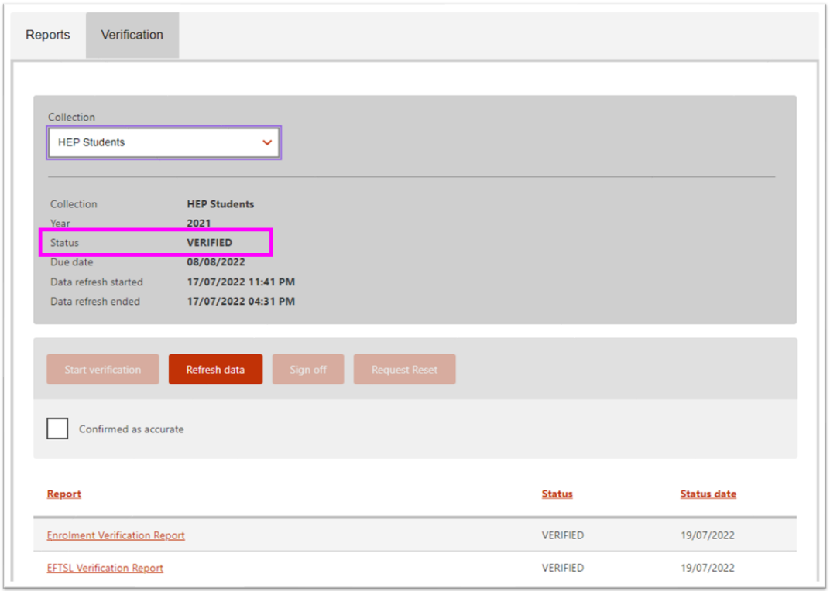

1. If the department rejects the ***Reset request*** the status for the collection will remain as ***Signed off*** and no further actions or changes can be made, your data is final, (Figure 30).

Figure 30 - Request Reset rejected

## Report slicer and Data Drill-through

### 8.1 Report slicers

Slicers are available for several reports to narrow down the data to be displayed. One or more categories can be displayed for each report. Selections within a slicer are generally available as multiple selections. Click on the down arrow to display the selection available within the sliver, (Figure 31).

Figure 31 - Report slicers

### 8.2 Data Drill-through

A drill-through report is available to display the data that made up the count in the report. To display the drill-through report:

1. Right click on the count required; and Select 'Drill through'; and Select 'Detail Report', (Figure 32).
2. The drill-through report is displayed, (Figure 33).

Figure 32 – Drill-through 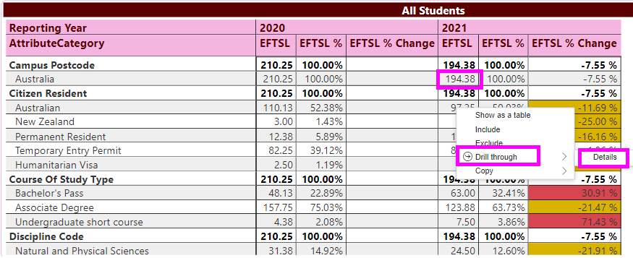

The drill-through generally contains the following;

Table 5 - Drill-through functions

| **Function** | **Purpose** |
| --- | --- |
|  | Used to return to the summary report |
| **You have drilled through on** | Lists each filter applied to generate the count on the summary report i.e., Year, Category. |

Figure 33 – Drill-through report

## Exporting reports

All reports and drill-throughs can be exported as xlsx files which the user can either open or save as required. To export data.

1. Click on the table of data to be exported
2. select the more options icon (…) to display the available options
3. Excel .xlsx option has a download limit of 150,000 rows
4. CSV has a download limit of 30,000 rows

Figure 34 - How to export reports

1. Select Export data, (Figure 35).

Figure 35 - Export data

1. Click Export, (Figure 36).

Figure 36 – Export to excel

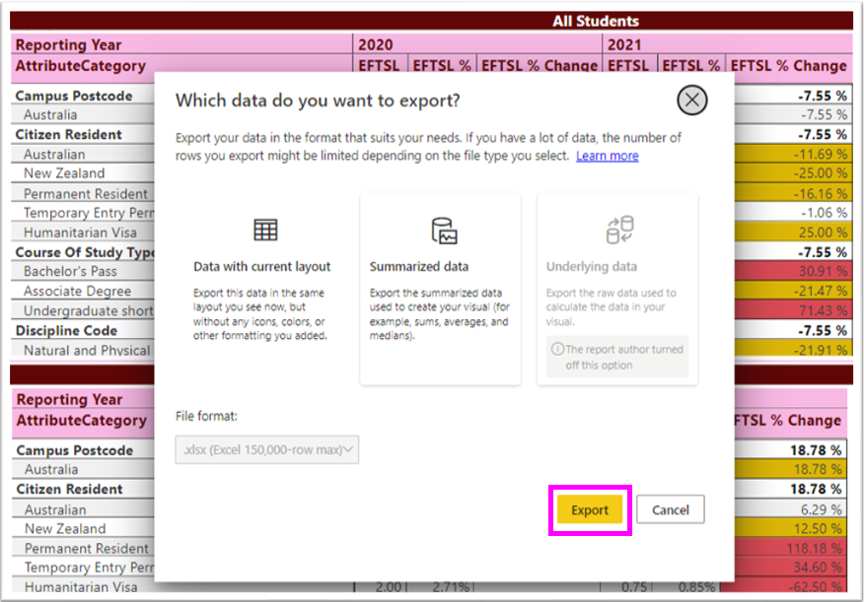

## Percentage change in data

Most reports will compare data for the selected year with data reported for the previous year. Where there is a significant percentage change, the system automatically highlights the differences - as these changes may be an indicator of incorrectly reported data or issues that require further investigation before signing off, (Figure 37).

Table 6 - Change variations identified in the following way

| **% Change** | **Variation Colour** | **Purpose** |
| --- | --- | --- |
| **Less than 10%** |  | Low |
| **Between 10% and 30%** |  | Intermediate |
| **Greater than 30%** |  | High |

Figure 37 – Change variation

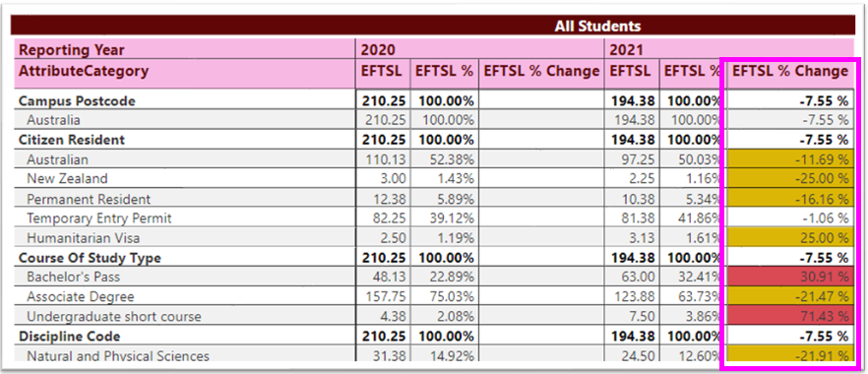

## Appendix

### Status and actions

The list of statuses and actions that occur during verification:

* **Activated:** The department has activated the collection and the reports are ready for checking. Whilst the status is activated the reports continue to be refreshed nightly.Once you have selected Start verification you have commenced the verification process for that collection, and the reports will remain static.
* **Verifying:** Verification is currently in progress. The verification process has been activated and the reports are ready to be assessed. If updates are required, you will need to refresh the report by selecting Refresh data to ensure any changes sent to TCSI are included in the reports and latest snapshot.
* **Refresh data**: The reports are updated overnight with latest data sent to TCSI. This action takes another snapshot to include data received prior to the refresh start date.
* **Verified:** All reports within the collection have been verified by the provider.
* **Signed off:** Data confirmed as accurate and is now final. This action has frozen all reports in the collection.
* **Request Reset:** If a collection has been signed off when it shouldn't have, or additional data has been provided that needs to be included in the reports, a Reset Request is required. This action will lock the collection and the relevant reports will not be available at this time. During this process no changes to the collection can be made until the department either accepts or rejects the reset request.
* **Accept Reset**: When the department accepts a Reset Request the collection status is reverted to Verified to allow the provider to restart verification. Once the reports are re-verified and Signed-Off the Request Reset button is enabled for further reset requests if required.
* **Reject Reset:** If the request for a reset is rejected by the department the Request Reset button is disabled and the collection remains locked. At this stage no further changes can be made to the reports as the department is in the process of finalising the collection for all providers.
* **Finalised:** The department will finalise the Collection after the verification period for providers has concluded. The collection is then closed, and the data is confirmed as verified. When a collection is finalised a sector snapshot is taken and stored, being an aggregation of the data signed off by each provider.

As a provider progresses through the verification process the collection, the report status will change and the processing buttons will either be enabled or disabled based on the actions performed. Table 7 outlines the processing changes that occur.

Table 7 – Collection, report status and processing functionality

| **Collection Status** | **Report Status** | **Start Verification button** | **Verification processing buttons** | | | |
| --- | --- | --- | --- | --- | --- | --- |
| **Verify (Reports)** | **Refresh** | **Sign Off** | **Request Reset** |
| *Department activated a collection, and the provider is yet to start verification* | | | | | | |
| **Activated** | Not verified | **Enabled** | Disabled | Disabled | Disabled | Disabled |
| *Provider started verification and yet to verify report(s)* | | | | | | |
| **Verifying** | Not verified | Disabled | **Enabled** | **Enabled** | Disabled | Disabled |
| *Provider has verified report(s)* | | | | | | |
| **Verifying** | Verified | Disabled | Disabled | **Enabled** | Disabled | Disabled |
| *Provider refreshed a collection, and the nightly refresh is completed* | | | | | | |
| **Activated** | Not verified | **Enabled** | Disabled | Disabled | Disabled | Disabled |
| *Provider has signed off a collection* | | | | | | |
| **Signed off** | **Verified** | Disabled | Disabled | Disabled | Disabled | **Enabled** |
| *Department has approved reset request for a signed off collection* | | | | | | |
| **Verified** | **Verified** | Disabled | Disabled | **Enabled** | Disabled | Disabled |
| *Department has rejected reset request for a signed off collection* | | | | | | |
| **Signed off** | **Verified** | Disabled | Disabled | Disabled | Disabled | Disabled |