

# TCSI fact sheet: Scheduled Validations

### What are Scheduled Validations

### Scheduled Validations (SVs) are about ensuring that records are complete and correct. These completeness checks cannot be done through real time validations (RTVs) because the fields are effectively optional until the deadline date for reporting. Further scheduled validation checks are required because the sequence of reporting is incompatible with an RTV. The scheduled validations work in conjunction with the RTVs. The scheduled validation prompts the provider to supply the data by the deadline and, once the data is submitted, the RTVs will check whether the values that have been reported are acceptable.

### When records are checked against the SV rules?

Records come into scope for being checked by SVs when the relevant trigger date is reached. This trigger date will be a set number of days before the deadline date for reporting. For example, the deadline for Unit enrolment data is 14 days after the census date. Completeness checks for Unit enrolment records will commence 7 days before the census date. This establishes a 'lead-in' of 21 days.

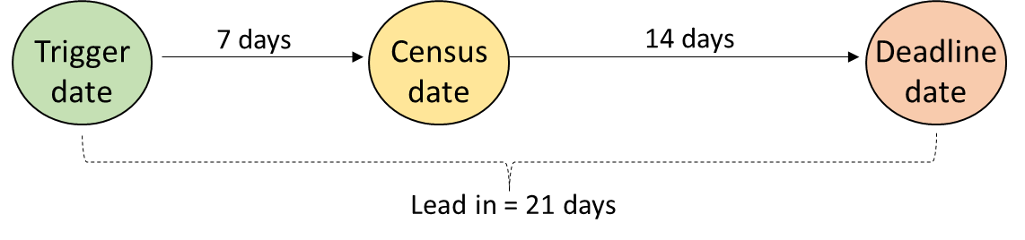

Once a record reaches a trigger date, that record and all records that are linked to it will be subject to the relevant scheduled validation rules.

### What happens when an SV rule finds incomplete data?

Where a record fails a scheduled validation check, a message will be placed on the provider's notification table to indicate what data is missing or is inconsistent. Once a provider supplies the necessary information to resolve the SV error, then the message will be deleted from the notifications table so that at any point in time, the notification table will only have scheduled validation messages that relate to data that is still incomplete or inconsistent. That is, SV messages will only appear on the notifications table by exception. If there are no SV messages on the provider's notifications table, this means that the system has not identified any incomplete or inconsistent records for that provider.

### When are system-generated scheduled validations executed?

System generated scheduled validations are executed overnight. For example, if the trigger date for a record is 24 March, the relevant scheduled validation will be executed overnight (between 6pm, 24 March and 6am and 25 March) so that the results of the scheduled validation are available for action by users from 6am, 25 March.

If a provider amends a record that has been subject to a scheduled validation, the re-execution of scheduled validations will also occur overnight. So, if the record was amended before 6pm on 28 March, the results of the re‑execution will be available from 6am on 29 March, at the latest.

|  |
| --- |
| Text in black are the validations that have been built and are in production |
| Text in blue indicates validations or amendments to validations that are planned to be released in the future |
| Text in red indicates validations that have been decommissioned |

### Validations Key

## Scheduled Event: Unit enrolment Census Date

Once a student reaches a census date for a particular unit enrolment, they incur a financial liability, and certain business processes are triggered, particularly where the student is Commonwealth assisted for the unit enrolment.

The deadline for reporting a range of debt and demographic data to TCSI is 14 days after the census date. The system will trigger the scheduled validations associated with each Unit enrolment record seven days before the unit of study census date (E489). Where a Unit enrolment record is reported late and is not received by TCSI before this deadline, the system will trigger a scheduled validation on the record and its linked records at the next opportunity (that is, that evening).

This event applies to both Higher Education Providers and VET Providers



|  |  |
| --- | --- |
| **Parameter** | **Specification** |
| Scope | New and amended Unit enrolment records submitted after 1st January 2021, where the student is enrolled at the end of the census date.  That is, only run these checks for records where the Unit of study outcome date (E601) is after the Unit of Study Census Date (E489). |
| Trigger date | Unit of Study Census date (E489) minus 7 days |
| Deadline date | Unit of Study Census date (E489) plus 14 days |
| Lead in Time | 21 days |
| Affected records | Unit enrolment  AOU  Course admission  Course  Course of study (HEP only)  Course on campus (HEP Only) / Delivery location (VET only)  Student |

### Rule Logic Table

| **Rule Number** | **Packet** | **Element** | **Rule** | **Notification Message** | **HEP** | **VET** |
| --- | --- | --- | --- | --- | --- | --- |
| SV00001 | Unit enrolment | Delivery location Country Code (E660) | If the Unit of Study Census date (E489) is on or after 1 January 2021, then E660 must not be blank (null) | Delivery location Country Code (E660) must be populated | Yes | No |
| SV00002 | Unit enrolment | Mode of attendance (E329) | E329 must not be blank (null) | Mode of attendance (E329) must be populated | Yes | Yes |
| SV00003 | Unit enrolment | Student Status Code (E490) | E490 must not be blank (null) | Student Status Code (E490) must be populated | Yes | Yes |
| SV00004 | Unit enrolment | Delivery location – postcode (E477) | If E660 is '1101', '1102', or '1199', then E477 must not be blank (null) | Delivery location – postcode (E477) must be populated for unit enrolments at Australian campuses | Yes | No |
| SV00005 | Unit enrolment | Maximum student contribution code (E392) | If E490 is '110', '111', '112', '201', '202', '203', '204', '250', '260', '261', '262', then E392 must not be blank (null) | Maximum student contribution code (E392) must be populated where the student is Commonwealth supported for the unit enrolment | Yes | No |
| SV00006 | Unit enrolment | Amount Charged (E384) | If E339 is not blank (null) on the unit enrolment record, then E384 must not be blank (null) on the unit enrolment record | Amount Charged (E384) must be populated on the unit enrolment record when the EFTSL (E339) is reported on the unit enrolment record | Yes | No |
| SV00007 | AOU Extension | Amount Charged (E384) | If E339 is not blank (null) on the unit enrolment AOU record, then E384 must not be blank (null) on the unit enrolment AOU record | Amount Charged (E384) must be populated on the unit enrolment AOU record when the EFTSL (E339) is reported on the unit enrolment AOU record | Yes | No |
| SV00008 | Unit enrolment | Amount Charged (E384) | E384 must not be blank (null) | Amount Charged (E384) must be populated | No | Yes |
| SV00009 | Unit enrolment | Amount paid upfront (E381) | If E339 is not blank (null) on the unit enrolment record, then E381 must not be blank (null) on the unit enrolment record | Amount paid upfront (E381) must be populated on the unit enrolment record when the EFTSL (E339) is reported on the unit enrolment record | Yes | No |
| SV00010 | AOU Extension | Amount paid upfront (E381) | If E339 is not blank (null) on the unit enrolment AOU record, then E381 must not be blank (null) on the unit enrolment AOU record | Amount paid upfront (E381) must be populated on the unit enrolment AOU record when the EFTSL (E339) is reported on the unit enrolment AOU record | Yes | No |
| SV00011 | Unit enrolment | Amount paid upfront (E381) | E381 must not be blank (null) | Amount paid upfront (E381) must be populated | No | Yes |
| SV00012 | Unit enrolment | Loan fee (E529) | If E339 is not blank (null) on the unit enrolment record, then E529 must not be blank (null) on the unit enrolment record | Loan fee (E529) must be populated on the unit enrolment record when the EFTSL (E339) is reported on the unit enrolment record | Yes | No |
| SV00013 | AOU Extension | Loan fee (E529) | If E339 is not blank (null) on the unit enrolment AOU record, then E529 must not be blank (null) on the unit enrolment AOU record | Loan fee (E529) must be populated on the unit enrolment AOU record when the EFTSL (E339) is reported on the unit enrolment AOU record | Yes | No |
| SV00014 | Unit enrolment | Loan fee (E529) | E529 must not be blank (null) | Loan fee (E529) must be populated | No | Yes |
| SV00015 | Unit enrolment | HELP loan amount (E558) | If E339 is not blank (null) on the unit enrolment record, then E558 must not be blank (null) on the unit enrolment record | HELP loan amount (E558) must be populated on the unit enrolment record when the EFTSL (E339) is reported on the unit enrolment record | Yes | No |
| SV00016 | AOU | HELP loan amount (E558) | If E339 is not blank (null) on the unit enrolment AOU record, then E558 must not be blank (null) on the unit enrolment AOU record | HELP loan amount (E558) must be populated on the unit enrolment AOU record when the EFTSL (E339) is reported on the unit enrolment AOU record | Yes | No |
| SV00017 | Unit enrolment | HELP loan amount (E558) | E558 must not be blank (null) | HELP loan amount (E558) must be populated | No | Yes |
| SV00018 | Course admission | Type of Attendance Code (E330) | E330 must not be blank (null) | Type of Attendance Code (E330) must be populated | No | Yes |
| SV00019 | Course admission | Highest attainment code (E620) | If the linked Course of Study Commencement Date (E534) is on or after 1 January 2021 and the Citizen resident code (E358) is '1', '2', '3' or '8' on the Unit of Study Census Date (E489), then E620 must not be blank (null) | Highest attainment code (E620) must be populated | Yes | Yes |
| SV00020 | Course admission | Study reason code (E575) | E575 must not be blank (null) | Study reason code (E575) must be populated | No | Yes |
| SV00021 | Course admission | Labour force status code (E576) | E576 must not be blank (null) | Labour force status code (E576) must be populated | No | Yes |
| SV00022 | Course admission | Australian Tertiary Admission Rank (E632) | If the linked Course of Study Commencement Date (E534) is on or after 1 January 2021 and E572 is less than or equal to the year of E534 minus 3 and E310 is '08', '09', '10', '13', '20', '21', '22' or '41' and E327 is '41' or '42', then E632 must not be blank | Australian Tertiary Admission Rank (E632) must be populated for recent school levers commencing an undergraduate course who have an Australian Tertiary Admission Rank (E632) | Yes | No |
| SV00023 | Course admission | Selection rank (E605) | If the linked Course of Study Commencement Date (E534) is on or after 1 January 2021 and E572 is less than or equal to the year of E534 minus 3 and E310 is '09', '10', '13', '20', '21', '22' or '41' and E327 is '41' or '42', then E605 must not be blank | Selection rank (E605) must be populated for recent school levers commencing an undergraduate course who have an Australian Tertiary Admission Rank (E632)[1] | Yes | No |
| SV00024 | Course admission | Type of Attendance Code (E330) | If E310 is '02' or '03', then E330 must not be blank (null) | Type of Attendance Code (E330) must be populated when the admission is for a higher degree by research course | Yes | No |
| SV00025 | Course admission | HDR Primary Field of Research (E594) | If the Unit of Study Census Date (E489) is on or after 1 January 2021 and E310 is '02' or '03', then E594 must not be blank (null) | Type of HDR Primary Field of Research (E594) must be populated when the admission is for a higher degree by research course | Yes | No |
| SV00026 | Course admission | Basis for admission code (E327) | E327 must not be blank (null) | Basis for admission code (E327) must be populated | Yes | Yes |
| SV00027 | Student | Gender code (E315) | E315 must not be blank (null) | Gender code (E315) must be populated | Yes | Yes |
| SV00028 | Student | Aboriginal and Torres Strait Islander code (E316) | E316 must not be blank (null) | Aboriginal and Torres Strait Islander code (E316) must be populated | Yes | Yes |
| SV00029 | Student | Country of birth code (E346) | E346 must not be blank (null) | Country of birth code (E346) must be populated | Yes | Yes |
| SV00030 | Student | Language spoken at home code (E348) | E348 must not be blank (null) | Language spoken at home code (E348) must be populated | Yes | Yes |
| SV00031 | Student | Residential address country code (E658) | If the Unit of Study Census Date (E489) is on or after 1 January 2021, then E658 must not be blank (null) | Residential address country code (E658) must be populated | Yes | Yes |
| SV00032 | Student | Term address country code (E661) | E661 must not be blank (null) | Term address country code (E661) must be populated | Yes | Yes |
| SV00033 | Student | Term address postcode (E319) | If E661 is '1101', '1102', or '1199', then E319 must not be blank (null) | Term address postcode (E319) must be populated when Term address country code (E661) is Australia | Yes | Yes |
| SV00034 | Student | Student family name (E402) | If E403 is '9999', then E402 must not be blank (null) | If a student only has one name, this must be populated in Student family name (E402) | Yes | Yes |
| SV00035 | Student | Year arrived in Australia (E347) | If E346 is not '1101', '1102' or '1199' and E661 is '1101', '1102' or '1199', then E347 must not be blank (null) | Year arrived in Australia (E347) must be populated for students residing in Australia but born overseas | Yes | No |
| SV00036 | Student | Year left school (E572) | If E358 is '1', '2', '3' or '8', then E572 must not be blank (null) | Year left school (E572) must be populated for a domestic student | Yes | Yes |
| SV00037 | Student | Level left school (E612) | If the Unit of Study Census Date (E489) is on or after 1 January 2021 and E358 is '1', '2', '3' or '8', then E612 must not be blank (null) | Level left school (E612) must be populated for a domestic student | Yes | Yes |
| SV00038 | Student | Highest educational attainment code parent 1 (E573) | If E358 is '1', '2', '3' or '8' and E310 on the linked course of study packet is '08', '09', '10', '13', '20', '21', '22', '30', '41', '60', then E573 must not be blank (null) | Highest educational attainment parent 1 (E573) must be populated for domestic undergraduate students | Yes | No |
| SV00039 | Student | Highest educational attainment code parent 2 (E574) | If E358 is '1', '2', '3' or '8' and E310 on the linked course of study packet is '08', '09', '10', '13', '20', '21', '22', '30', '41', '60', then E574 must not be blank (null) | Highest educational attainment parent 2 (E574) must be populated for domestic undergraduate students | Yes | No |
| SV00040 | Student | Tax file number (E416) | If E558 (HELP loan amount) is greater than 0 and Unit of study outcome date (E601) is greater than the Unit of Study Census Date (E489), then E416 (Tax file number) must not be blank (null) | Tax file number (E416) must be populated for a domestic student who is enrolled at the census date and is accessing a loan | Yes | Yes |
| SV00041 | Student | CHESSN (E488) | If E490 (Student Status Code) on the linked Unit enrolment packet is '401' to '410', then E488 must not be blank (null) | CHESSN (E488) must be populated for students accessing a VSL loan | No | Yes |
| SV00042 | Student | CHESSN (E488) | If E490 (Student Status Code) on the linked Unit enrolment packet is '110', '111', '112', '201', '202', '203', '204', '220', '230', '231', '232', '233', '250', '260', '261', '262', then E488 must not be blank (null) | CHESSN (E488) must be populated for Commonwealth assisted students | Yes | No |
| SV00043 | Student | CHESSN (E488) | If E490 (Student Status) is '331' and the Citizen resident code (E358) is '1', '2', '3' or '8' on the Unit of Study Census Date (E489), then E488 must not be blank (null) | CHESSN (E488) must be populated for a domestic student receiving support under the Research Training Program | Yes | No |
| SV00044 | Student | Unique Student Identifier (E584) | If E490 (Student Status Code) is '400' to '410', then E584 must not be blank (null) | Unique Student Identifier (E584) must be populated for Commonwealth assisted students | No | Yes |
| SV00045 | Student | Citizen resident code (E358) | Citizen resident code (E358) must not be blank (null) | Citizen resident code (E358) must be populated and be current on the Unit of Study Census Date (E489) | Yes | Yes |
| SV00046 | Unit enrolment | Course assurance indicator (E619) | If the Unit of Study Census Date (E489) is on or after 1 January 2021, then E619 must not be blank (null) | Course assurance indicator (E619) must be populated | No | Yes |
| SV00099 | Unit Enrolment/ AOU | Student Status Code (E490) | If a Student Status Code (E490) is '202' for a Student (UID8) with more than one Unit Enrolment record (UID16) with the same Unit of Study Census Date (E489), then for all Unit Enrolment records (UID16) that the Student (UID8) has with the same Unit of Study Census Date (E489) and the Unit of Study Outcome Date (E601) is after the Unit of Study Census Date (E489), the Student Status Code (E490) must not be '110', '112', '201' or '203'. | Please check the Student Status Code (E490) for all unit enrolment records for the Student (UID8) with the same Unit of Study Census Date (E489). If a student is a Commonwealth supported student for a unit of study on a given census date, they must be consistently coded as a full up-front payer or consistently coded as accessing a full or partial HECS-HELP loan for all units of study with the same census date, unless they are ineligible for a HECS-HELP loan for a particular unit of study. If a Student Status Code (E490) is '202', then there must not be another Student Status Code (E490) of '110', '112', '201' or '203' for the student on the same census day. | Yes | No |
| SV00100 | Unit Enrolment/ AOU | Student Status Code (E490) | If a Student Status Code (E490) is '201' for a Student (UID8) with more than one Unit Enrolment record (UID16) with the same Unit of Study Census Date (E489), then for all Unit Enrolment records (UID16) that the Student (UID8) has with the same Unit of Study Census Date (E489) and the Unit of Study Outcome Date (E601) is after the Unit of Study Census Date (E489), the Student Status Code (E490) must not be '111', '112', '202' or '203'. | Please check the Student Status Code (E490) for all unit enrolment records for the Student (UID8) with the same Unit of Study Census Date (E489). If a student is a Commonwealth supported student for a unit of study on a given census date, they must be consistently coded as a full up-front payer or consistently coded as accessing a full or partial HECS-HELP loan for all units of study with the same census date, unless they are ineligible for a HECS-HELP loan for a particular unit of study. If a Student Status Code (E490) is '201', then there must not be another Student Status Code (E490) of '111', '112', '202' or '203' for the student on the same census day. | Yes | No |
| SV00102 | Unit Enrolment | Course Assurance Indicator (E619) | If the Course Assurance Indicator (E619) is not blank (null) for more than one Unit Enrolment (UID16) linked to the same Course Admission (UID15) and the Unit of Study Census Date (E489) is on or after 1 July 2021, then the Course Assurance Indicator (E619) must be the same for all such Unit Enrolment records (UID16) linked to that Course Admission (UID15) record. | Please check the Course Assurance Indicator (E619) for each Unit Enrolment record that is linked to the Course Admission record (UID15) and has a Unit of Study Census Date (E489) on or after 1 July 2021. The Course Assurance Indicator (E619) must be consistently 'true' or consistently 'false' for all the Unit Enrolment records linked to the same Course Admission Record (UID15) where the Unit of Study Census Date (E489) is on or after 1 July 2021. | No | Yes |
| SV00103 | AOU | Amount Charged (E384) | If Student Status Code (E490) is '110' to '112' or '201' to '204' and Amount Charged (E384) is reported through the AOU Unit Enrolments extension, then the sum of all Amounts Charged (E384) must have 0 cents. | Please check each Amount Charged (E384) for the unit enrolment record. Student contribution amounts must be rounded down to the nearest dollar. When student contribution amounts are reported in Amounts Charged (E384) across multiple AOUs for a given unit enrolment record, they must therefore sum to a whole dollar amount. | Yes | No |
| SV00104 | Student | Unique Student Identifier (E584) | If the Student Status Code (E490) is '201', '202', '203', '204', '230' or '231' and the Unit of Study Census Date (E489) is on or after 1 January 2021 and before 1 January 2023 and the Course of Study Commencement Date (E534) is on or after 1 January 2021, then the Unique Student Identifier (E584) must not be blank (null) | Unique Student Identifier (E584) must be populated for Commonwealth assisted students with a Course of Study Commencement Date (E534) on or after 1 January 2021 and a Unit of Study Census Date (E489) after 1 January 2021. | Yes | Yes |
| SV00105 | Student | Unique Student Identifier (E584) | If the Student Status Code (E490) is '201', '202', '203', '204', '230', '231', '232' or '233' and the Unit of Study Census Date (E489) is on or after 1 January 2023, then the Unique Student Identifier (E584) must not be blank (null). | Unique Student Identifier (E584) must be populated for Commonwealth assisted students with a Unit of Study Census Date (E489) on or after 1 January 2023. | Yes | Yes |
| SV00108 | Student | Unique Student Identifier (E584) | If the Student Status Code (E490) is '401', '402', '403', '404', '405', '406', '407', '408', '409' or '410' and the Course of Study Commencement Date (E534) is on or after 1 January 2021, then the Unique Student Identifier (E584) must not be blank (null). | Unique Student Identifier (E584) must be populated for Commonwealth assisted students with a Course of Study Commencement Date (E534) on or after 1 January 2021. | No | Yes |
| SV00117 | Unit Enrolment AOU | Student Status Code (E490) | If a Student Status Code (E490) is '201' for a Student (UID8) with more than one Unit Enrolment record (UID16) with the same Unit of Study Census Date (E489) where Student Status Code (E490) is '201', then for all Unit Enrolment records (UID16) with the same Unit of Study Census Date (E489) and same Student (UID8) and Student Status Code (E490) of '201', the sum of Amounts Paid Upfront (E381) must be less than the sum of Amounts Charged (E384) multiplied by the Discount Rate. | Please check the Student Status Code (E490) for all unit enrolment records for the Student (UID8) with the same Unit of Study Census Date (E489). If student is eligible for HECS-HELP (E490 is '201') but the student has made a full upfront payment on all unit enrolments on the Unit of Study Census Date (E489), the unit enrolments must be coded as full upfront with a discount (E490 is '202'). If the student is a Commonwealth supported student who is not eligible for HECS-HELP, the unit enrolments must be coded as full upfront without a discount (E490 is '203'). | Yes | No |

## Scheduled Event: Unit Enrolment Census Date for upfront discounts (HE Only)

It is not possible to check upfront discount calculations using real-time validations. The following SVs are intended to check the consistency of coding for Student Status Code (E490) and the calculation of loan amounts depending on the applicability of discounts.

These checks are triggered 7 days after the census date so that providers receive notifications before loans are potentially finalised and sent to the ATO 14 days after the census date.

This event applies only to Higher Education Providers only.

|  |  |
| --- | --- |
| **Parameter** | **Specification** |
| Scope | Records potentially eligible for an upfront discount |
| Trigger date | Unit of Study Census Date (E489) plus 7 days |
| Deadline date | Unit of Study Census Date (E489) plus 14 days |
| Lead In Time | 7 days |
| Affected records | Unit Enrolment  AOU |

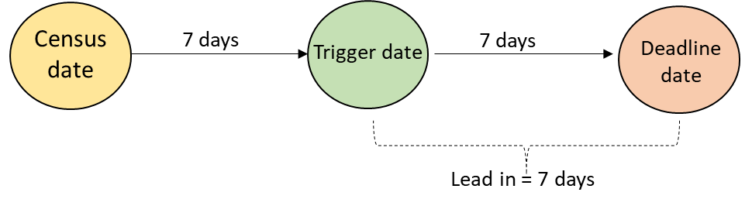

### Rule Logic Table

| **Rule Number** | **Packet** | **Element** | **Rule** | **Notification Message** | **HEP** | **VET** |
| --- | --- | --- | --- | --- | --- | --- |
| SV00096 | Unit Enrolment/ AOU | Amounts Paid Upfront (E381) | Where E490 is ‘111’ or ‘202’  If Total E381 = (Total E384 x Lookup.UpfrontDiscount_DiscountRate) ± 0.20, then delete the record from the ‘dbo.UnitsForUpFrontDiscountProcessing’ table  Else place notification message on the provider’s table with reference to each of the Unit Enrolment records (UID16) affected | The sum of Amounts Charged (E384) multiplied by the applicable discount does not equal sum of Amounts Paid Upfront (E381). | Yes | No |
| SV00097 | Unit Enrolment/ AOU | HELP Loan Amount (E558) | Where the E490 is ‘110’ or ‘201’  If Total E381 < 500  If Total E558 = Total E384 *minus* Total E381  Then delete the record from the ‘dbo.UnitsForUpFrontDiscountProcessing’ table  Else place notification message on the provider’s table with reference to each of the Unit Enrolment records (UID16) affected | Loan processing cannot proceed because the HELP Loan Amount (E558) does not equal the Amount Charged (E384) minus the Amount Paid Upfront (E381). | Yes | No |
| SV00098 | Unit Enrolment/ AOU | HELP Loan Amount (E558) | Where the E490 is ‘110’ or ‘201’  If Total E381 >= 500  If Total E384 *minus* Total E381 *divided by* Lookup.UpfrontDiscount_DiscountRate = Total E558 ± 0.10.  Then delete the record from the ‘dbo.UnitsForUpFrontDiscountProcessing’ table  Else place notification message on the provider’s table with reference to each of the Unit Enrolment records (UID16) affected | Loan processing cannot proceed because the sum of HELP Loan Amounts (E558) does not equal the sum of Amounts Charged (E384) minus sum of Amounts Paid Upfront (E381) divided by the applicable upfront discount rate. | Yes | No |
| SV00115 | Unit Enrolment | Amount Paid Upfront (E381) | For each record on the ‘dbo.UnitsForUpFrontDiscountProcessing’ table that has a census date (E489) that is 7 days in the past: If the sum of Amounts Paid Upfront (E381) for all the AOUs linked to the UE is greater than [the sum of Amounts Charged (E384) for all the AOUs linked to the UE multiplied by Lookup.UpfrontDiscount_DiscountRate] ± 0.20 then send a provider notification to the provider. | The Amount Paid Upfront (E381) for a unit enrolment exceeds the maximum amount payable once the applicable discount is applied to the Amount Charged (E384) | Yes | No |
| SV00116 | Unit Enrolment | Loan Amount (E558) | If any of the HELP Loan Amounts (E558) for any of the AOUs linked to the UE does not equal 0.00, then send a provider notification to the provider. | A loan amount (E558) has been reported for a unit enrolment where the student has been reported as a full up-front payer (E490=’202’ or ‘111’) or fully paid with discount (E490 = ‘201’ or ‘110’). | Yes | No |

## Scheduled event: OS-HELP debt incurral date

When an OS-HELP debt is incurred, the linked student is considered to be Commonwealth assisted and all information required by that status must be supplied.

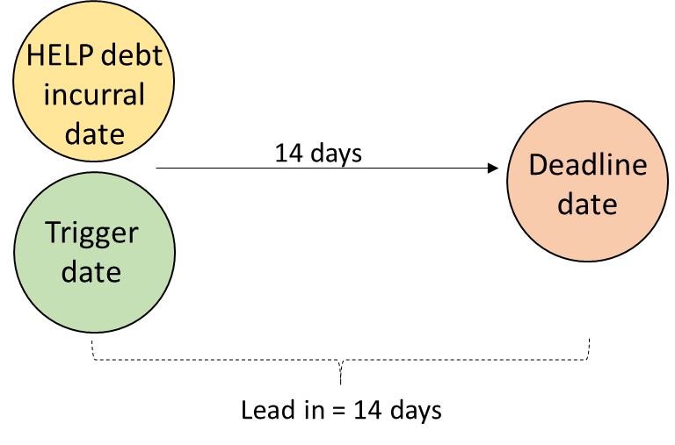This event applies only to Higher Education Providers

|  |  |
| --- | --- |
| **Parameter** | **Specification** |
| Scope | All new and amended records submitted after 1st January 2021 |
| Trigger date | HELP debt incurral date (E527) on an OS-HELP record |
| Deadline date | HELP debt incurral date (E527) plus 14 days |
| Lead in Time | 14 days |
| Affected records | OS-HELP loan  Course admission  Course  Course of study  Student |

### Rule Logic Table – HEPs only

| **Rule Number** | **Packet** | **Element** | **Rule** | **Notification Message** | **HEP** | **VET** |
| --- | --- | --- | --- | --- | --- | --- |
| SV00047 | OS-HELP loan | Loan fee (E529) | Loan Fee (E529) must not be blank (null) | Loan fee (E529) must be populated for OS-HELP Debts | Yes | No |
| SV00048 | OS-HELP loan | OS-HELP primary study country code (E553) | If the ~~HELP debt incurral date (E527) is on or after 1 January 2006 and~~ E490 is '240' or '241', then E553 must not be blank | OS-HELP primary study country code (E553) must be populated where the OS-HELP loan is for overseas study | Yes | No |
| SV00049 | OS-HELP loan | OS-HELP data packet | If the OS-HELP Language Study Commencement Date (E583) is not blank for an OS-HELP loan record ('Record A') for a Student (E313)/Provider (E306) combination, there must be another OS-HELP loan record ('Record L') for the Student (E313)/Provider (E306) combination where the Student Status Code (E490) is '242' and the OS-HELP Study Period Commencement Date (E521) on Record L matches the OS-HELP Language Study Commencement Date (E583) on Record A. | A matching OS-HELP language study loan must be reported where an OS-HELP study loan indicates that the student has received a language study loan in connection with their overseas study | Yes | No |
| SV00050 | OS-HELP loan | OS-HELP language code (E582) | If Student Status Code (E490) is '242', then E582 must not be blank | OS-HELP language code (E582) must be populated when accessing an OS-HELP language loan | Yes | No |
| SV00051 | Student | Gender code (E315) | E315 must not be blank (null) | Gender code (E315) must be populated | Yes | No |
| SV00052 | Student | Aboriginal and Torres Strait Islander code (E316) | E316 must not be blank (null) | Aboriginal and Torres Strait Islander code (E316) must be populated | Yes | No |
| SV00053 | Student | Country of birth code (E346) | E346 must not be blank (null) | Country of birth code (E346) must be populated | Yes | No |
| SV00054 | Student | Language spoken at home code (E348) | E348 must not be blank (null) | Language spoken at home code (E348) must be populated | Yes | No |
| SV00055 | Student | Residential address country code (E658) | If the HELP debt incurral date (E527) is on or after 1 January 2021, then E658 must not be blank (null) | Residential address country code (E658) must be populated | Yes | No |
| SV00056 | Student | Term address country code (E661) | E661 must not be blank (null) | Term address country code (E661) must be populated | Yes | No |
| SV00057 | Student | Term address postcode (E319) | If E661 is '1101', '1102', or '1199', then E319 must not be blank (null) | Term address postcode (E319) must be populated when Term address country code (E661) is Australia | Yes | No |
| SV00058 | Student | Year arrived in Australia (E347) | If E346 is not '1101', '1102' or '1199' and E661 is '1101', '1102' or '1199', then E347 must not be blank (null) | Year arrived in Australia (E347) must be populated for students residing in Australia but born overseas | Yes | No |
| SV00059 | Student | Year left school (E572) | If E358 is '1', '2', '3' or '8', then E572 must not be blank (null) | Year left school (E572) must be populated for a domestic student | Yes | No |
| SV00060 | Student | Level left school (E612) | If the HELP debt incurral date (E527) is on or after 1 January 2021 and E358 is '1', '2', '3' or '8', then E612 must not be blank (null) | Level left school (E612) must be populated for a domestic student | Yes | No |
| SV00061 | Student | Highest educational attainment code parent 1 (E573) | If E358 is '1', '2', '3' or '8' and E310 on the linked course of study packet is '08', '09', '10', '13', '20', '21', '22', '30', '41', '60', then E573 must not be blank (null) | Highest educational attainment parent 1 (E573) must be populated for domestic undergraduate students | Yes | No |
| SV00062 | Student | Highest educational attainment code parent 2 (E574) | If E358 is '1', '2', '3' or '8' and E310 on the linked course of study packet is '08', '09', '10', '13', '20', '21', '22', '30', '41', '60', then E574 must not be blank (null) | Highest educational attainment parent 2 (E574) must be populated for domestic undergraduate students | Yes | No |
| SV00063 | Student | Tax file number (E416) | The E416 (Tax file number) must not be blank (null) | Tax file number (E416) must be populated for a student accessing an OS‑HELP loan | Yes | No |
| SV00064 | Student | CHESSN (E488) | E488 must not be blank (null) | CHESSN (E488) must be populated for a student accessing an OS‑HELP loan | Yes | No |
| SV00065 | Student | Citizen resident code (E358) | Citizen resident code (E358) must not be blank (null) | Citizen resident code (E358) must be populated | Yes | No |
| SV00095 | OS-HELP loan | OS-HELP data packet | If the Student Status Code (E490) is '242' for a loan record (Record L) for a Student (E313)/Provider (E306) combination, then there must be another OS-HELP loan record ('Record A') for the Student (E313)/Provider (E306) combination where the Student Status Code (E490) is '241' and the OS-HELP Language Commencement Date (E583) matches the OS‑HELP Study Period Commencement Date (E521) on Record L. | A matching OS-HELP overseas study loan must be reported for a student where an OS-HELP language loan has been reported for the student | Yes | No |
| SV00106 | OS-HELP | Unique Student Identifier (E584) | If the Student Status Code (E490) is '240', '241' or '242' and the HELP Debt Incurral Date (E527) is on or after the 1 January 2021, then the Unique Student Identifier (E584) must not be blank (null) and must be verified. | Unique Student Identifier (E584) is overdue for OS-HELP debts with a HELP Debt Incurral Date (E527) on or after 1 January 2021. | Yes | No |

## Scheduled event: SA-HELP debt incurral date

When a SA-HELP debt is incurred, the linked student is considered to be Commonwealth assisted and all information required by that status must be supplied.

This event applies only to Higher Education Providers



|  |  |
| --- | --- |
| **Parameter** | **Specification** |
| Scope | All new and amended records submitted after 1st January 2021 |
| Trigger date | HELP debt incurral date (E527) on an SA-HELP record |
| Deadline date | HELP debt incurral date (E527) plus 14 days |
| Lead in time | 14 days |
| Affected records | Student  SA-HELP |

### Rule Logic Table – HEPs only

| **Rule Number** | **Packet** | **Element** | **Rule** | **Notification Message** | **HEP** | **VET** |
| --- | --- | --- | --- | --- | --- | --- |
| SV00066 | Student | Gender code (E315) | E315 must not be blank (null) | Gender code (E315) must be populated | Yes | No |
| SV00067 | Student | Aboriginal and Torres Strait Islander code (E316) | E316 must not be blank (null) | Aboriginal and Torres Strait Islander code (E316) must be populated | Yes | No |
| SV00068 | Student | Country of birth code (E346) | E346 must not be blank (null) | Country of birth code (E346) must be populated | Yes | No |
| SV00069 | Student | Language spoken at home code (E348) | E348 must not be blank (null) | Language spoken at home code (E348) must be populated | Yes | No |
| SV00070 | Student | Residential address country code (E658) | If the HELP debt incurral date (E527) is on or after 1 January 2021, E658 must not be blank (null) | Residential address country code (E658) must be populated | Yes | No |
| SV00071 | Student | Term address country code (E661) | E661 must not be blank (null) | Term address country code (E661) must be populated | Yes | No |
| SV00072 | Student | Term address postcode (E319) | If E661 is '1101', '1102', or '1199', then E319 must not be blank (null) | Term address postcode (E319) must be populated when Term address country code (E661) is Australia | Yes | No |
| SV00073 | Student | Year arrived in Australia (E347) | If E346 is not '1101', '1102' or '1199' and E661 is '1101', '1102' or '1199', then E347 must not be blank (null) | Year arrived in Australia (E347) must be populated for students residing in Australia but born overseas | Yes | No |
| SV00074 | Student | Year left school (E572) | If E358 is '1', '2', '3' or '8', then E572 must not be blank (null) | Year left school (E572) must be populated for a domestic student | Yes | No |
| SV00075 | Student | Level left school (E612) | If the HELP debt incurral date (E527) is on or after 1 January 2021 and E358 is '1', '2', '3' or '8', then E612 must not be blank (null) | Level left school (E612) must be populated for a domestic student | Yes | No |
| SV00076 | Student | Highest educational attainment code parent 1 (E573) | If E358 is '1', '2', '3' or '8' and E310 on the linked course of study packet is '08', '09', '10', '13', '20', '21', '22', '30', '41', '60', then E573 must not be blank (null) | Highest educational attainment parent 1 (E573) must be populated for domestic undergraduate students | Yes | No |
| SV00077 | Student | Highest educational attainment code parent 2 (E574) | If E358 is '1', '2', '3' or '8' and E310 on the linked course of study packet is '08', '09', '10', '13', '20', '21', '22', '30', '41', '60', then E574 must not be blank (null) | Highest educational attainment parent 2 (E574) must be populated for domestic undergraduate students | Yes | No |
| SV00078 | Student | Tax file number (E416) | The E416 (Tax file number) must not be blank (null) | Tax file number (E416) must be populated for a student accessing an SA‑HELP loan | Yes | No |
| SV00079 | Student | CHESSN (E488) | CHESSN (E488) must not be blank (null) | CHESSN (E488) must be populated for a student accessing an SA‑HELP loan | Yes | No |
| SV00080 | Student | Citizen Resident Code (E358) | Citizen Resident Code (E358) must not be blank (null) | Citizen Resident Code (E358) must be populated | Yes | No |
| SV00107 | SA-HELP | Unique Student Identifier (E584) | If the Student Status Code (E490) is '280' or '281' and the HELP Debt Incurral Date (E527) is on or after the 1 January 2023, then the Unique Student Identifier (E584) must not be blank (null) and must be verified. | Unique Student Identifier (E584) is overdue for SA-HELP debts with a HELP Debt Incurral Date (E527) on or after 1 January 2023. | Yes | No |

## Scheduled event: Course Completion

When a Course admission is recorded as being complete, all unit enrolments linked to that course must have an outcome associated with them. The Course Outcome Date (E592) that drives this validation can only be populated (based on the real time validations) if the course has actually been completed. This event applies to both Higher Education Providers and VET Providers.

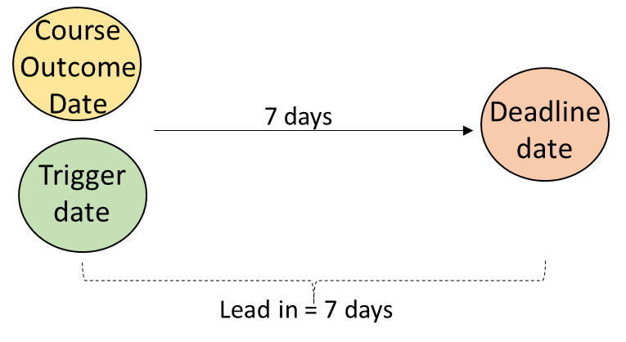

|  |  |
| --- | --- |
| **Parameter** | **Specification** |
| Scope | Course admissions records with a Course Outcome Date (E592) on or after 1st January 2021 |
| Trigger date | Course Outcome Date (E592) |
| Deadline date | Course Outcome Date (E592) plus 7 days |
| Lead in time | 7 days |
| Affected records | Course admission  Unit enrolment |

### Rule Logic Table

| **Rule Number** | **Packet** | **Element** | **Rule** | **Notification Message** | **HEP** | **VET** |
| --- | --- | --- | --- | --- | --- | --- |
| SV00081 | Course admission | Course outcome code (E599) | If E592 is not blank (null) and the Course Outcome Date (E592) is on or after 1 January 2021, then E599 must not be blank (null) | Course outcome code (E599) must be populated when Course Outcome Date (E592) indicates that the student has completed the course | Yes | Yes |
| SV00082 | Course admission  Aggregated Award | Higher degree by research thesis submission date (E591) | If Course of Study Type (E310) of '01', '02' or '03', then Higher Degree by Research Thesis Submission Date (E591) must not be blank (null) | Higher degree by research thesis submission date (E591) must be populated for students that have completed a higher degree by research course | Yes | No |
| SV00083 | Course admission | Specialisation Code (E463) | E463 must not be blank (null) except where Course of Study Type (E310) is 30, 41, 42 or 50. | Specialisation Code (E463) must be populated | Yes | No |
| SV00084 | Student | Year of arrival in Australia (E347) | If E346 is not '1101', '1102' or '1199' and E661 is '1101', '1102' or '1199', then E347 must not be blank (null) | Year arrived in Australia (E347) must be populated for students residing in Australia but born overseas | Yes | No |
| SV00085 | Student | Citizen resident code (E358) | Citizen resident code (E358) must not be blank (null) | Citizen resident code (E358) must be populated | Yes | No |
| SV00086 | Unit enrolment | Unit of study status code (E355) | E355 must not be '4' for units with unit of study census date (E489) on or after 1 January 2021 | Unit of study status code (E355) must not be '4' for unit enrolment records that are linked to a completed course. | Yes | Yes |
| SV00119 | Course Admission | Course Outcome Date (E592) | For a student who has an active Citizen Resident Code (E358) of ‘1’, ‘2’, ‘3’, ‘4’ or ‘8’ (Domestic and international onshore students) on the Course Outcome Date (E592), where the Course Outcome Date (E592) reported that is on or after 1 January 2023, then the Unique Student Identifier (E584) must not be blank (null) and must be verified. | Unique Student Identifier (E584) must be verified for domestic or international onshore student with a Course Outcome Date (E592) on or after 1 January 2023 | Yes | No |

## Scheduled event: Course Completion/HDR end-user engagement

When a Course admission is recorded as being complete any HDR end-user engagements should be have been ended. While it is the Course Outcome Date (E592) that triggers the need to look for HDR end-user engagement records that are still incorrectly active, the deadline date for the reporting of the HDR end-user engagement Effective to date (E610) is 31 January of the year after the Course Outcome Date (E592).

This event applies to both Higher Education Providers only

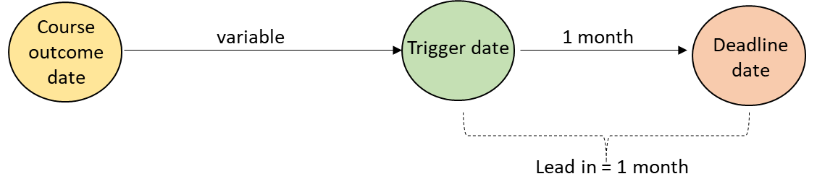

|  |  |
| --- | --- |
| **Parameter** | **Specification** |
| Scope | Course admissions records with a Course Outcome Date (E592) on or after 1st January 2021 |
| Trigger date | 1 January |
| Deadline date | 31 January |
| Lead in time | 1 month |
| Affected records | HDR end-user engagement |

### Rule Logic Table – HEPs only

| **Rule Number** | **Packet** | **Element** | **Rule** | **Notification Message** | **HEP** | **VET** |
| --- | --- | --- | --- | --- | --- | --- |
| SV00087 | HDR end-user engagement | HDR end-user engagement Effective to date (E610) | If the Course Admission has one or more linked HDR end-user engagement records, the HDR End-user Engagement Effective To Date (E610) must not be blank (null) | HDR end-user engagement Effective to date (E610) must be populated for HDR end-user engagement records that are linked to a completed course. | Yes | No |
| SV00118 | Aggregate Awards | HDR Thesis Submission Date (E591) | If Course of Study Type (E310) of '01', '02' or '03', then HDR Thesis Submission Date (E591) must not be blank (null) | HDR Thesis Submission Date (E591) must be populated for students that have completed a higher degree by research course. | Yes | No |

## Scheduled event: Course on campus Effective from date

For Course on campus records, providers are required to supply data before a student is admitted to a course on campus. However, course admissions records in TCSI are linked to a course, rather than a course on campus so it is not possible to establish a trigger point for the scheduled validations that directly reflects the reporting requirements.

Those reporting requirements still stand but the scheduled validations will use 'proxy' trigger and deadline dates. For any course on campus records with a Course on campus Effective from date (E609) in the:

* first half of the year, the deadline date for completion of the record will be 30 June of that year
* second half of the year, the deadline date for completion of the record will be 31 December of that year

The trigger point will be one month from those dates, that is, 31 May and 30 November.

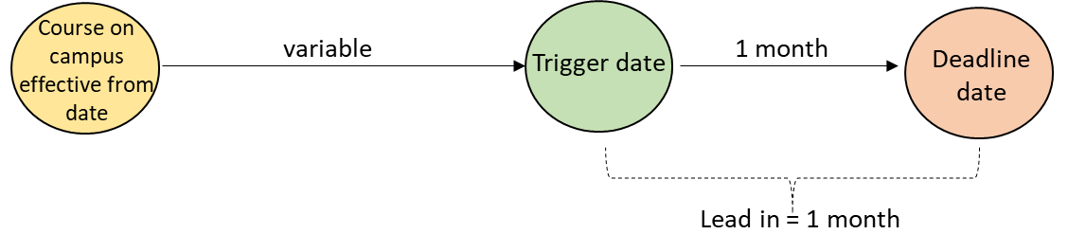

|  |  |
| --- | --- |
| **Parameter** | **Specification** |
| Scope | All course on campus records reported from 1 January 2021 |
| Trigger date | 31 May for course on campuses commencing in the first half of the year  30 November for course on campuses commencing in the second half of the year |
| Deadline date | 30 June for course on campuses commencing in the first half of the year  30 December for course on campuses commencing in the second half of the year |
| Lead in time | 1 month |
| Affected records | Course on campus  Course campus fees |

### Rule Logic Table – HEP only

|  |  |  |  |  |  |  |
| --- | --- | --- | --- | --- | --- | --- |
| **Rule Number** | **Packet** | **Element** | **Rule** | **Notification Message** | **HEP** | **VET** |
| SV00088 | Course on campus | Campus operation type (E569) | If Offshore Delivery Code (E571) is '01' or '02', then Campus operation type (E569) must not be blank (null). | Campus operation type (E569) must be populated for offshore campuses | Yes | No |
| SV00089 | Course on campus | Principal mode of offshore delivery code (E570) | If Offshore Delivery Code (E571) is '01' or '02', then Principal Mode of Offshore Delivery Code (E570) must not be blank (null). | Principal mode of offshore delivery code (E570) must be populated for offshore campuses | Yes | No |
| SV00090 | Campus Course Fees | Indicative student contribution amount for a Commonwealth supported place (E495) | If the Course Fees Code (E536) is '1' or '3', then Indicative Student Contribution Amount for a Commonwealth Supported Place (E495) must not be blank (null). | Indicative student contribution amount for a Commonwealth supported place (E495) must be populated for courses in which Commonwealth supported places are offered | Yes | No |
| SV00091 | Campus Course Fees | Indicative tuition fee for a domestic fee–paying place (E496) | If the Course Fees Code (E536) is '2' or '3', then Indicative Tuition Fee for a Domestic Fee-paying Place (E496) must not be blank (null). | Indicative tuition fee for a domestic fee–paying place (E496) must be populated for courses in which domestic fee-paying places are offered | Yes | No |

## Scheduled event: End of reporting period (Commonwealth Scholarship records)

From 2021, providers will be required to report the Commonwealth scholarship amount (E598) for students with an active scholarship during the six-month scholarship period.

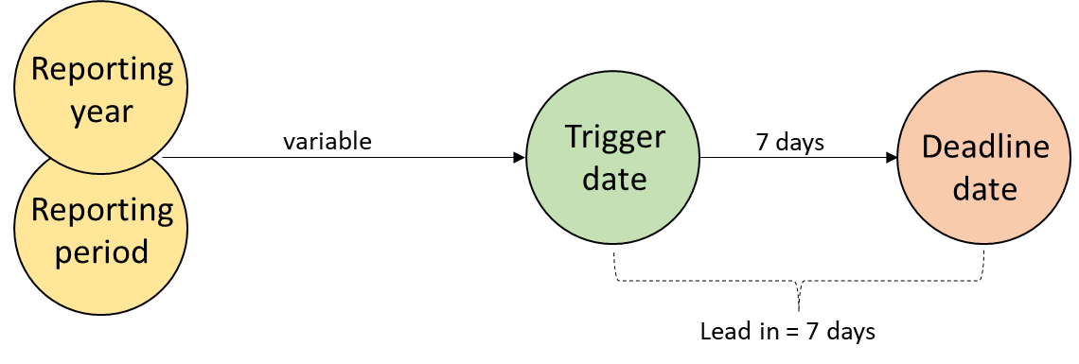

|  |  |
| --- | --- |
| **Parameter** | **Specification** |
| Scope | All Commonwealth Scholarship records reported with a reporting year (E415) of 2021 or later |
| Trigger date | 1 July for first half year records (E666 is '1')  1 January second half year records (E666 is '2') |
| Deadline date | 7 July for first half year records (E666 is '1')  7 January for second half year records (E666 is '2') |
| Lead in time | 7 days |
| Affected records | Commonwealth scholarships |

### Rule Logic Table – HEP only

|  |  |  |  |  |  |  |
| --- | --- | --- | --- | --- | --- | --- |
| **Rule Number** | **Packet** | **Element** | **Rule** | **Notification Message** | **HEP** | **VET** |
| SV00092 | Commonwealth scholarships | Commonwealth scholarship amount (E598) | If Commonwealth Scholarship Status Code (E526) is '1', then Commonwealth Scholarship Amount (E598) not be blank (null). | Commonwealth scholarship amount (E598) must be populated for students with an active Commonwealth Scholarship | Yes | No |

## ~~Scheduled event: Scholarship~~

~~Within 7 days of the commencement of a Research Training Program (RTP) scholarship, the provider is required to report the scholarship effective to date (E610) for that scholarship.~~

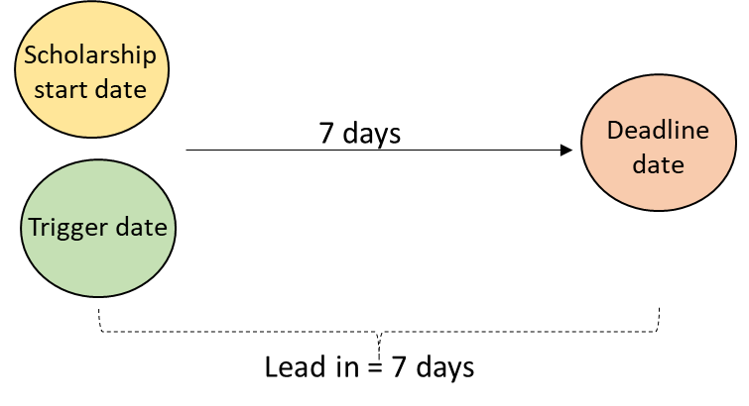

|  |  |
| --- | --- |
| ~~Parameter~~ | ~~Specification~~ |
| ~~Scope~~ | ~~All new and amended scholarship records from 1 January 2021~~ |
| ~~Trigger date~~ | ~~Scholarship Effective from date (E609)~~ |
| ~~Deadline date~~ | ~~Scholarship Effective from date (E609) plus 7 days~~ |
| ~~Lead in time~~ | ~~7 days~~ |
| ~~Affected records~~ | ~~Scholarship~~ |

Rule Logic Table

|  |  |  |  |  |  |  |
| --- | --- | --- | --- | --- | --- | --- |
| **Rule Number** | **Packet** | **Element** | **Rule** | **Notification Message** | **HEP** | **VET** |
| ~~SV00093~~ | ~~Scholarship~~ | ~~Scholarship Effective to date (E610)~~ | ~~Scholarship Effective to date (E610) must not be blank (null)~~ | ~~Scholarship Effective to date (E610) must be populated~~ | ~~Yes~~ | ~~No~~ |

## Scheduled event: Unit of study commencement date

Within 7 days a student enrolling in a unit of study, the provider is required to report the EFTSL amounts for that unit enrolment. The EFTSL value must be consistent for all students in the same unit of study in the same period, where the unit contributes to the same course of study. Fatal, real-time validation rules prevent the reporting of inconsistent EFTSL (E339) where the EFTSL is reported in the main 'unit enrolment' packet. However, a similar real-time validation rule could not be executed where providers report the EFSTL as part of the 'AOU extension' packet because these packets are processed sequentially in TCSI. This sequential processing means that any real-time rule would be triggered on almost every occasion where the unit enrolment has more than one AOU code. A scheduled validation will be needed to check for this inconsistency at the point after which all EFTSL values for a unit enrolment should have been reported.

There is no enrolment date in so the unit of study commencement date (E600) is used as a trigger for this check.

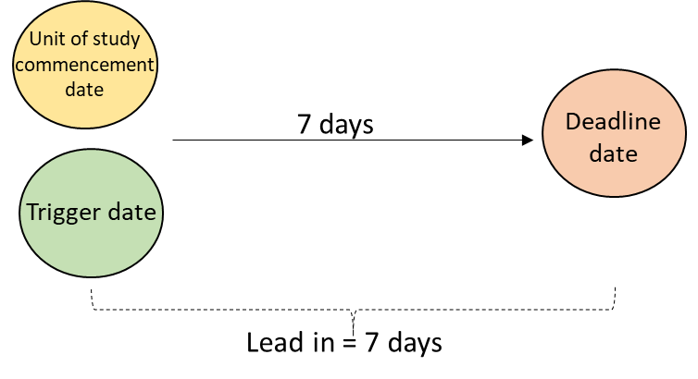

|  |  |
| --- | --- |
| **Parameter** | **Specification** |
| Scope | All new and amended unit enrolment records from 1 January 2020, with EFTSL reported in the AOU extension packet |
| Trigger date | Unit of study commencement date (E600) |
| Deadline date | Unit of study commencement date (E600) plus 7 days |
| Lead in time | 7 days |
| Affected records | AOU extension |

### Rule Logic Table

|  |  |  |  |  |  |  |
| --- | --- | --- | --- | --- | --- | --- |
| **Rule Number** | **Packet** | **Element** | **Rule** | **Notification Message** | **HEP** | **VET** |
| SV00094 | AOU extension | EFSTL (E339) | For each Unit Enrolment record with the same combination of Course of Study (UID3)/ Unit of Study Code (E354)/ Unit of Study Commencement Date (E600)/ Unit of Study Outcome Date (E601), where the Unit of Study Status Code (E355) is '4' and the Course of Study Type (E310) is not '02' or '03', the sum of EFTSLs (E339) Enrolment record must be consistent. | The sum of all EFTSL (E339) values for a Unit enrolment record must be the same for all students enrolled in the same unit of study in the same period if they are enrolled in the same course of study. | Yes | No |

## Scheduled event: Unique Student Identifier (USI)

From 1 January 2021, new higher education students must have a [Unique Student Identifier (USI)](https://www.tcsisupport.gov.au/element/584) to be eligible for a [Commonwealth supported place (CSP)](https://www.tcsisupport.gov.au/glossary/glossaryterm/Commonwealth%20supported%20place) and Commonwealth financial assistance ([HECS-HELP](https://www.tcsisupport.gov.au/glossary/glossaryterm/HECS-HELP), [FEE-HELP](https://www.tcsisupport.gov.au/glossary/glossaryterm/FEE-HELP) or [OS-HELP](https://www.tcsisupport.gov.au/glossary/glossaryterm/OS-HELP)).

|  |  |
| --- | --- |
| **Parameter** | **Specification** |
| Scope | Commonwealth assisted students with a Course of Study Commencement Date (E534) after 1 January 2021 |
| Trigger date | Unit of Study Census Date (E489) |
| Deadline date | Unit of Study Census Date (E489) |
| Lead in time | 14 days |
| Affected records | Student  Course Admission  Unit Enrolment |

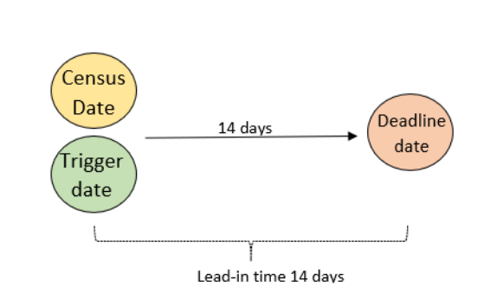Within 14 days of the earliest census date for the student, the provider is required to report the Unique Student Identifier for the student.

### Rule Logic Table

| **Rule Number** | **Packet** | **Element** | **Rule** | **Notification Message** | **HEP** | **VET** |
| --- | --- | --- | --- | --- | --- | --- |
| SV00109 | Student | Unique Student Identifier (E584) | If the Student Status Code (E490) is '201', '202', '203', '204', '230' or '231' and the Unit of Study Census Date (E489) is on or after 1 January 2021 and the Course of Study Commencement Date (E534) is on or after 1 January 2021, then the Unique Student Identifier (E584) must not be blank (null) and must be verified. | Unique Student Identifier (E584) must be verified for Commonwealth assisted students with a Course of Study Commencement Date (E534) on or after 1 January 2021 and a Unit of Study Census Date (E489) on or after 1 January 2021. | Yes | No |
| SV00110 | Student | Unique Student Identifier (E584) | If the Student Status Code (E490) is '232' or '233' and the Unit of Study Census Date (E489) is on or after 1 January 2023, then the Unique Student Identifier (E584) must not be blank (null) and must be verified. | Unique Student Identifier (E584) must be verified for Commonwealth assisted students with a Unit of Study Census Date (E489) on or after 1 January 2023. | Yes | No |
| SV00111 | Student | Unique Student Identifier (E584) | If the Student Status Code (E490) is '401', '402', '403', '404', '405', '406', '407', '408', '409' or '410' and the Course of Study Commencement Date (E534) is on or after 1 January 2021, then the Unique Student Identifier (E584) must not be blank (null) and must be verified. | Unique Student Identifier (E584) must be verified for Commonwealth assisted students with a Course of Study Commencement Date (E534) on or after 1 January 2021. | No | Yes |

|  |  |
| --- | --- |
| **Parameter** | **Specification** |
| Scope | Commonwealth assisted students with a Course of Study Commencement Date (E534) after 1 January 2021 |
| Trigger date | Unit of Study Census Date (E489) plus 14 days |
| Deadline date | Unit of Study Census Date (E489) plus 14 days |
| Lead in time | 14 days |
| Affected records | Student  Course Admission  Unit Enrolment |

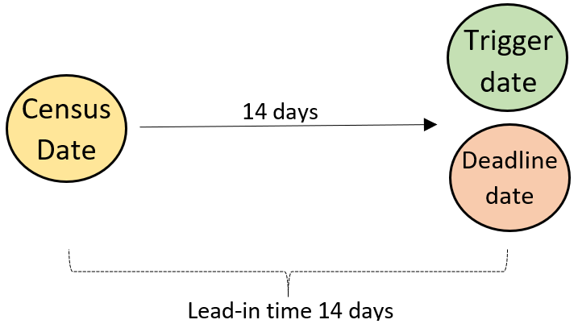

### Rule Logic Table

| **Rule Number** | **Packet** | **Element** | **Rule** | **Notification Message** | **HEP** | **VET** |
| --- | --- | --- | --- | --- | --- | --- |
| SV00112 | Student | Unique Student Identifier (E584) | If the Student Status Code (E490) is '201', '202', '203', '204', '230' or '231' and the Unit of Study Census Date (E489) is on or after 1 January 2021 and the Course of Study Commencement Date (E534) is on or after 1 January 2021, then the Unique Student Identifier (E584) must not be blank (null) and must be verified. | Unique Student Identifier (E584) verification is now overdue for Commonwealth assisted students with a Course of Study Commencement Date (E534) on or after 1 January 2021 and a Unit of Study Census Date (E489) after 1 January 2021. | Yes | No |
| SV00113 | Student | Unique Student Identifier (E584) | If the Student Status Code (E490) is '232' or '233' and the Unit of Study Census Date (E489) is on or after 1 January 2023, then the Unique Student Identifier (E584) must not be blank (null) and must be verified. | Unique Student Identifier (E584) verification is now overdue for Commonwealth assisted students with a Course of Study Commencement Date (E534) on or after 1 January 2023 and a Unit of Study Census Date (E489) after 1 January 2023. | Yes | No |
| SV00114 | Student | Unique Student Identifier (E584) | If the Student Status Code (E490) is '401', '402', '403', '404', '405', '406', '407', '408', '409' or '410' and the Course of Study Commencement Date (E534) is on or after 1 January 2021, then the Unique Student Identifier (E584) must not be blank (null) and must be verified. | Unique Student Identifier (E584) is now overdue for Commonwealth assisted students with a Course of Study Commencement Date (E534). | No | Yes |

1. Reference here to E632 is deliberate. If a student has an ATAR (which is tested using E327) then they have a selection rank because the specifications for E605 state that E605=E632 where there is no adjustment.