# HIGHER EDUCATION SUPPORT ACT 2003

## Notice under subsection 19-70(1)

I, Nicholas Post, Assistant Secretary, Market Analysis and Data Branch, Department of Education, delegate of the Minister for Education under paragraph 238-5(1)(b) of the [*Higher Education Support Act 2003*](https://www.legislation.gov.au/Series/C2004A01234)(HESA) for the purposes of subsection 19-70(2) of HESA, require you to give to me data for the 2023 Higher Education Data Collections, requirements for which are set out in the 2023 Higher Education Data Requirements and Change Control document.

I approve the form in which all 2023 data must be lodged, via the following submission channels:

* APIs (Application Programming Interface) for system-to-system submission; or
* file upload to the TCSI Data Entry portal.

All 2023 reporting requirements can be accessed at: [www.tcsisupport.gov.au](https://www.tcsisupport.gov.au/)

The detailed requirements for these submission methods are available at the [www.tcsisupport.gov.au](https://www.tcsisupport.gov.au/) site or by contacting TCSI Support at [TCSIsupport@education.gov.au](mailto:TCSIsupport@education.gov.au).

You are required to check for any changes that may, from time to time, be made to the data requirements. All changes to the requirements for the Higher Education Data Collection will be noted in the 2023 Higher Education Data Requirements and Change Control document.

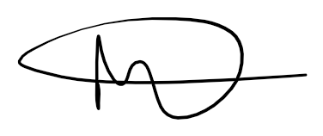

Dr Nicholas Post

Assistant Secretary

Market Analysis and Data Branch

20 December 2022