

**TCSI Analytics**

**User Guide**

**for**

**Providers**

**Version 0.2 February 2021**

**Contents**

1. Access to TCSI 3

1.1 URL 3

1.2 TCSI Access Page 3

1.3 TCSI Access Components 4

1.4 Authentication 5

1.4.1 Authentication Type 5

1.4.2 Login to PRODA 6

1.4.3 Verification 7

1.4.4 Terms and Conditions 7

1.4.5 TCSI Analytics Portal 8

2. TCSI Analytics Portal 9

2.1 User Interface Layout 9

2.2 Banner 9

2.3 User Identification 9

2.4 Activities 10

2.5 Activity Area 11

2.6 Footer 11

3. Reports Tab 12

3.1 Tab Layout 12

3.2 Report Filters 13

3.3 Report List 14

4. Report 15

4.1 Report Layout 15

4.2 Report Identification and Report Functions 15

4.3 Report Area 16

4.3.1 Report Filters 16

4.3.2 Summary Report 16

4.3.3 Drill-through Report Layout 17

4.3.4 Exporting your reports 18

4.3.5 Focus Mode 19

5. Appendix A Report details 20

5.1 VET Student Loans reports 20

5.2 Higher education reports 22

# Access to TCSI

## URL

TCSI Access is the access point for TCSI services. A link to TCSI Access is maintained in a button in the banner of the TCSI Support website at <https://www.tcsisupport.gov.au/>.

It is recommended to use one of the following web browsers when accessing TCSI services;

* Google Chrome
* Microsoft Edge Chromium
* Firefox

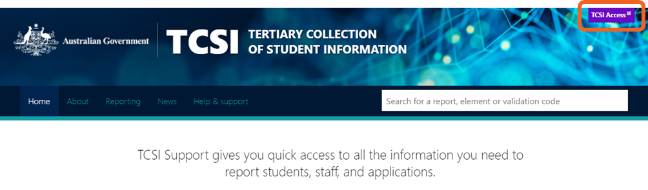

## 1.2 TCSI Access Page

When the TCSI Access button is used, the following *TCSI Access* page is displayed:

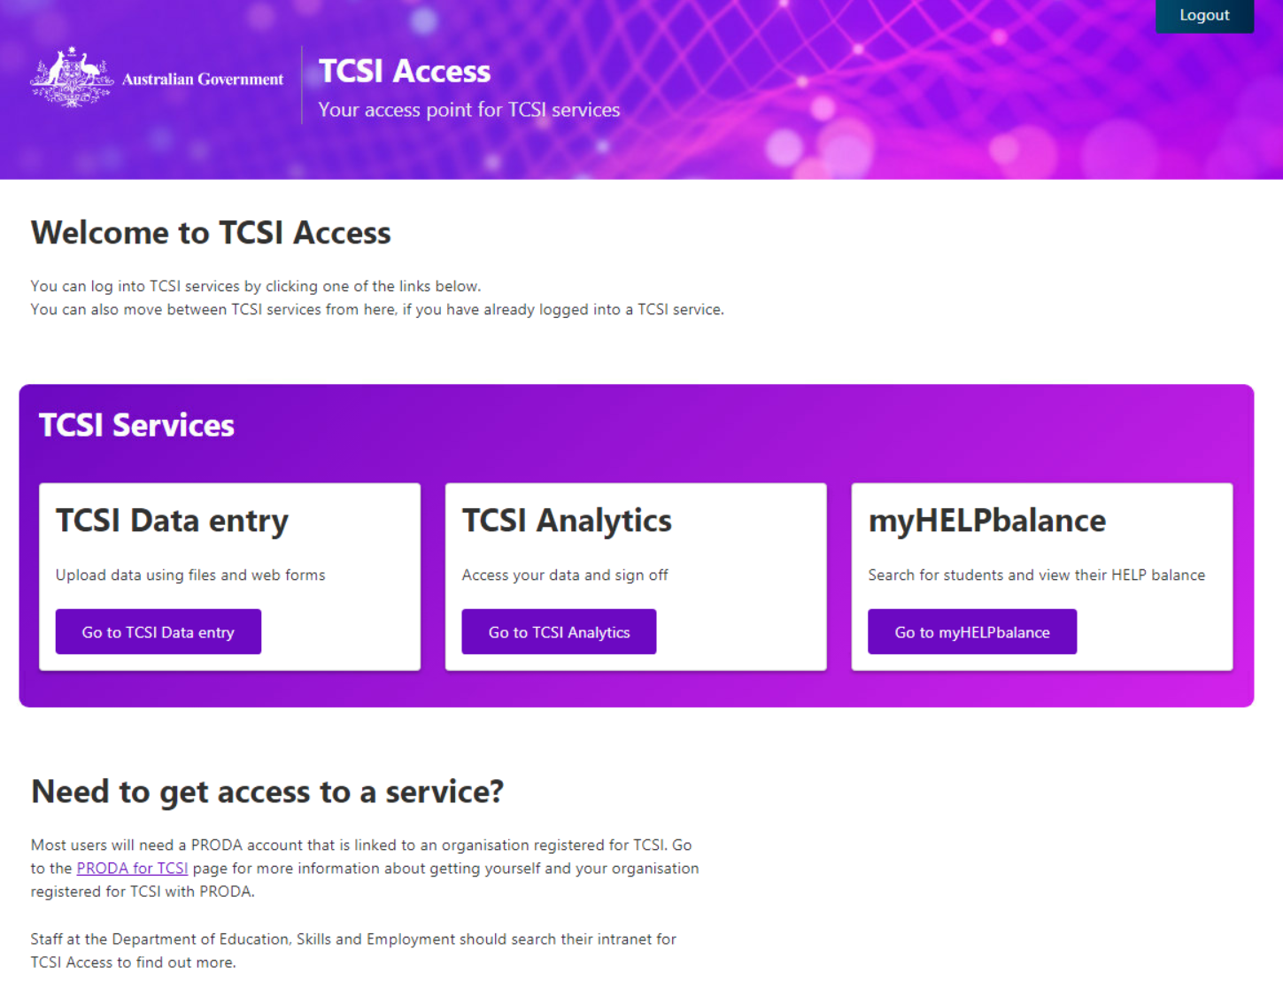

## 1.3 TCSI Access Components

#### Logout



At any time during the session, you can log out of TCSI Access by clicking “Logout” in the banner.

#### TCSI Services

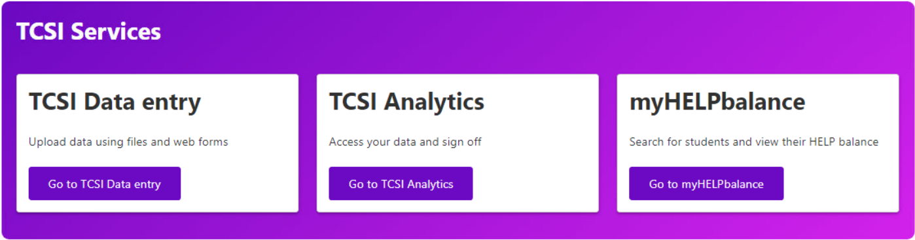

The tiles present within the TCSI Services section provide access to the entire suite of TCSI applications that are currently available.

| **Tile** | **Purpose** |
| --- | --- |
|  | Click the Go to TCSI Data entry link to access the *TCSI Data Entry* page where TCSI data can be submitted. |
|  | Click the Go to TCSI Analytics link to access the *TCSI Analytics* page where TCSI data can be viewed via a series of reports. |
|  | Click the Go to myHELPbalance link to access the *myHELPbalance* page to display entitlement information for a student. |

Click the Go to TCSI Analytics link to access the TCSI Analytics portal.

## 1.4 Authentication

### 1.4.1 Authentication Type

Whenever a TCSI service has been selected, and you have not yet been authenticated, the following authentication tiles are displayed:

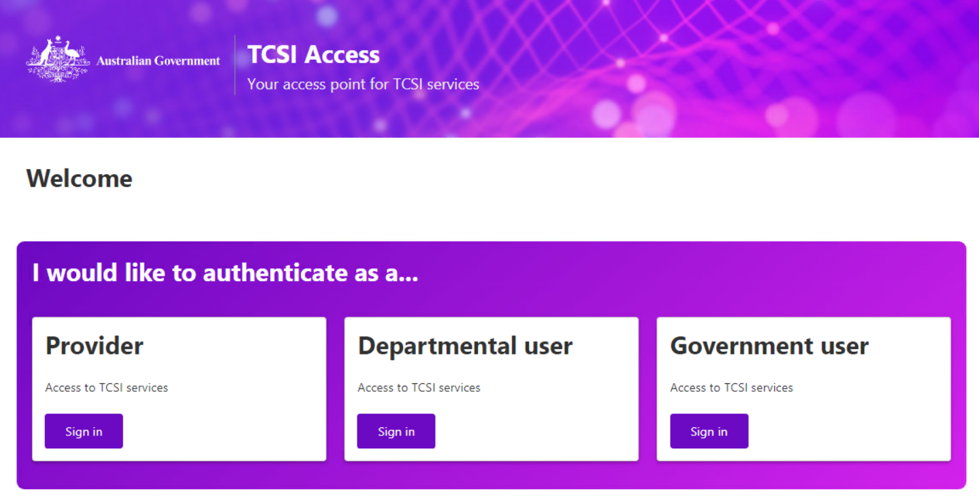

| **Tile** | **Purpose** |
| --- | --- |
|  | To be used by providers who have submitted TCSI data and/or are required to view submitted TCSI data. |
|  | To be used by internal departmental users who have a business need to view submitted TCSI data. |
|  | To be used by Federal or State Government agency users who have a business need to view submitted TCSI data.  A separate guide will be available for Government users. |

Click the Sign in link in the Provider tile to authenticate as a provider.

### 1.4.2 Login to PRODA

When you have chosen to authenticate as a provider, the following *Provider Digital Access* page is displayed:

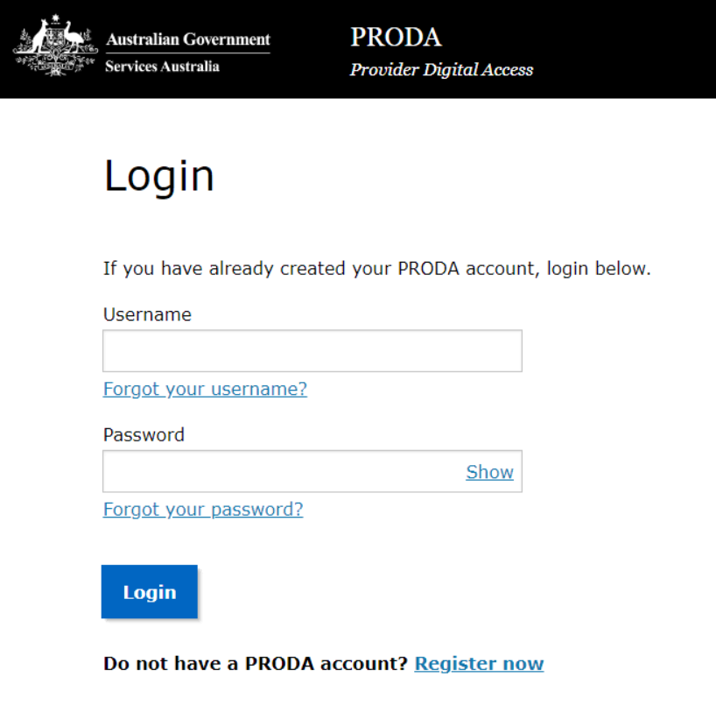

If you have a current PRODA account with appropriate roles:

* Enter your username; and
* Enter your password; and

Click Login.

Follow the guidance on the TCSI Support [Access (PRODA)](https://www.tcsisupport.gov.au/support/proda) page if you do not have a current PRODA account that has been assigned appropriate roles by an education provider that is linked to the TCSI Service. To log in to TCSI Analytics for your provider, a member of your organisation will need to assign the “TCSI Analytics – Read” role.

### 1.4.3 Verification

When you have entered your login credentials, the following is displayed:

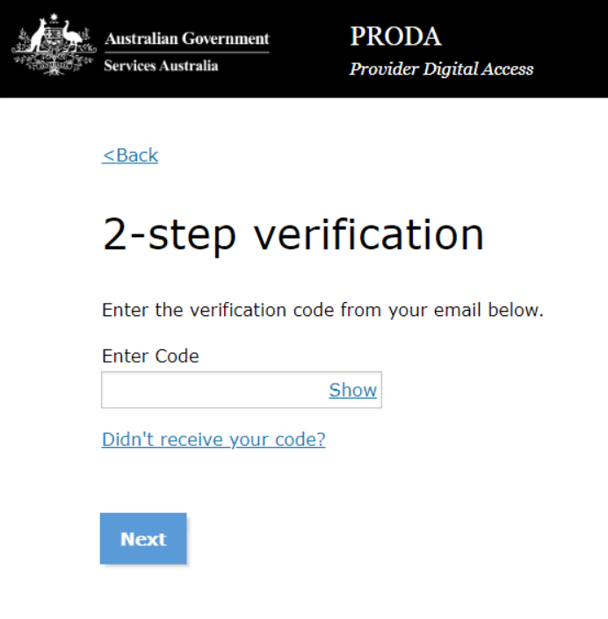

Enter the Provider Digital Access verification code that has been sent to you and click Next.

### 1.4.4 Terms and Conditions

When you have entered the verification code, the following is displayed:

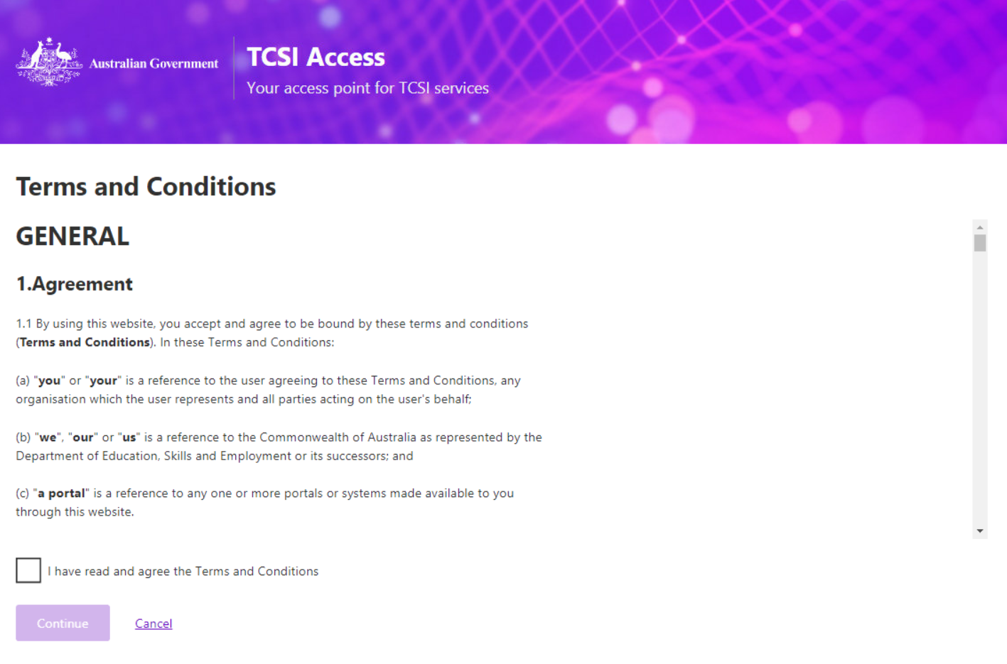

Read the terms and conditions and:

* Click the ‘I have read and agree to the Terms and Conditions; and
* Click Continue.

### 1.4.5 TCSI Analytics Portal

When you acknowledged the terms and conditions, the TCSI Analytics portal is displayed. For example:

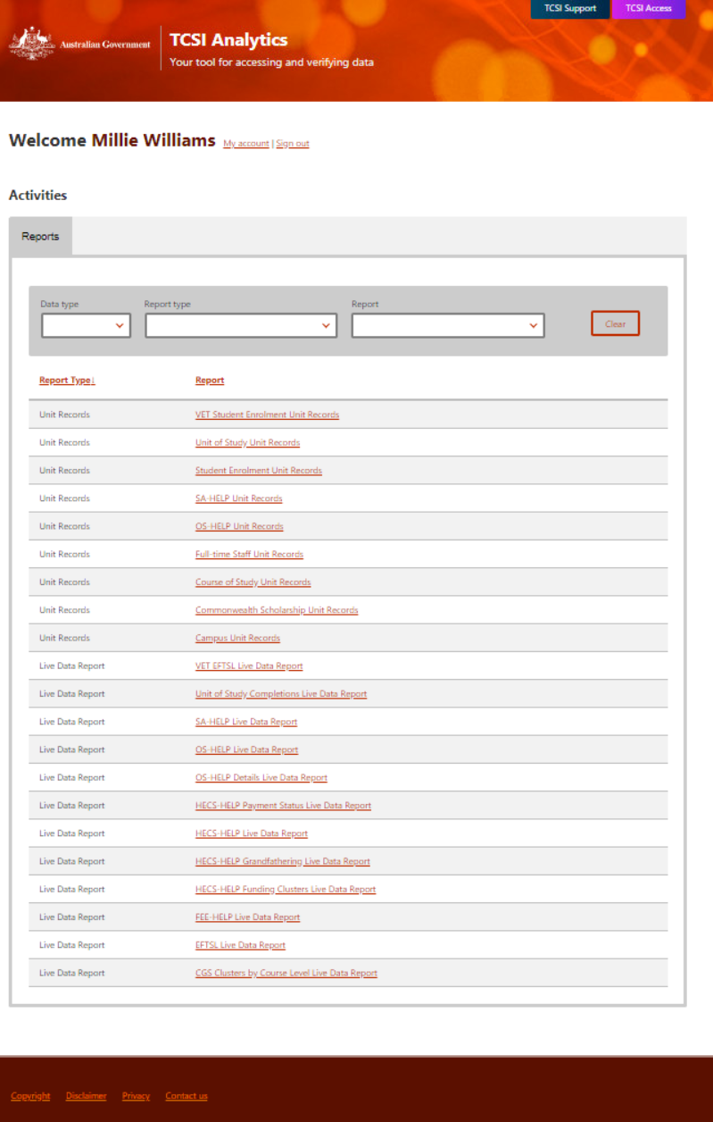

# TCSI Analytics Portal

## 2.1 User Interface Layout

The TCSI Analytics user interface is laid out in the following order:

* Banner
* Welcome
* Activities
* Activities tab area
* Footer.

## 2.2 Banner



#### TCSI Support

The ‘TCSI Support’ link can be used to take you to the TCSI Support page.

#### TCSI Access

The ‘TCSI Access’ link can be used to take you back to the *TCSI Access* page.

## 2.3 User Identification



#### User Name

The welcome message includes the full name of the user accessing TCSI Analytics.

#### My Account

Click the My account link to display your access details. For example:

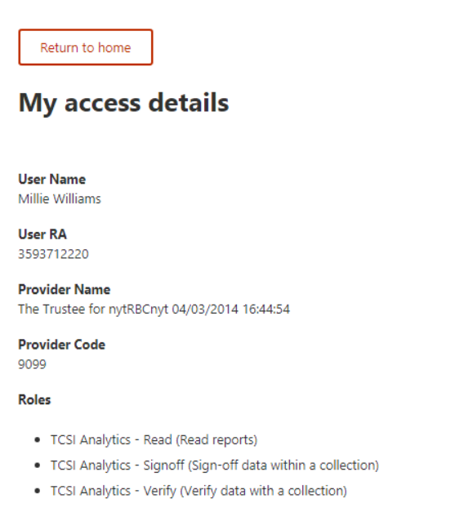

The following information is passed in by PRODA when you logged in:

* User name
* User RA number
* Provider name
* Provider code
* Roles.

Click the Return to home link to remove the access details.

#### Sign Out

Click the Sign out link to close down the TCSI Analytics portal.

**Note:** Other TCSI applications that you have opened will need to be closed down separately.

## 2.4 Activities

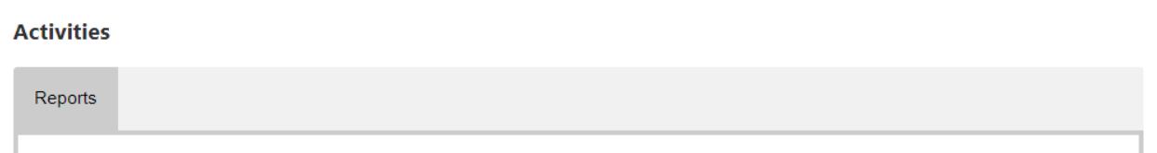

The functions (activities) that can be performed by a user are displayed as tabs across the page immediately under the user identification.

Currently, the *Reports* tab is the only tab available.

## 2.5 Activity Area

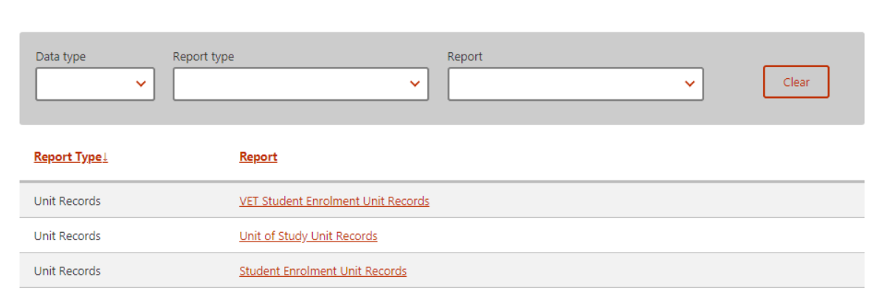

This area is the functional section that is to be used for each activity.

## 2.6 Footer



The following hyperlinks are provided in the footer:

| **Hyperlink** | **Imbedded URL** |
| --- | --- |
| Copyright | <https://www.dese.gov.au/copyright> |
| Disclaimer | <https://www.dese.gov.au/disclaimer> |
| Privacy | <https://www.dese.gov.au/privacy-policy> |
| Contact us | [TCSIsupport@dese.gov.au](mailto:TCSIsupport@dese.gov.au) |

# Reports Tab

## 3.1 Tab Layout

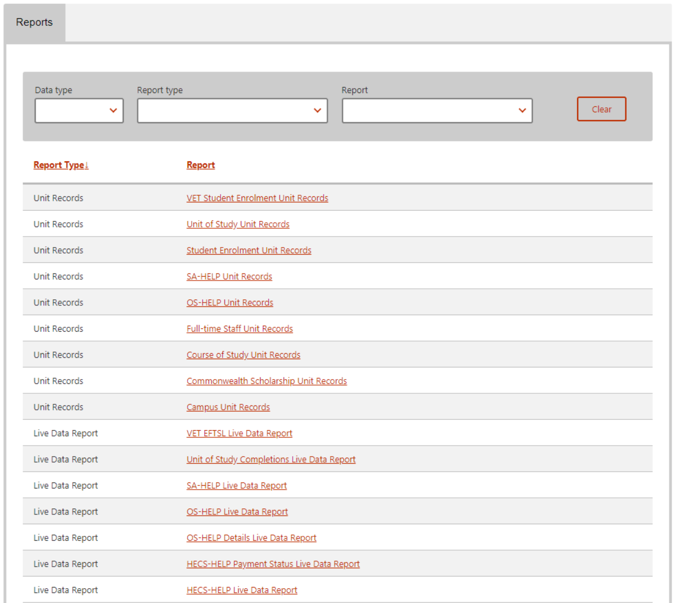

The Reports tab is laid out in the following order:

* Report filters
* Report list.

## 3.2 Report Filters

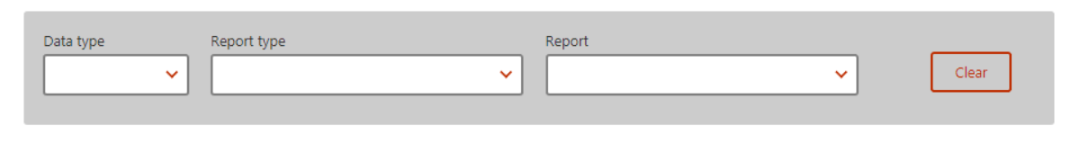

On initial access to the *Reports* tab, all reports that you are authorised to view are displayed.

The list of reports can be refined by using the following filters:

| **Filter/Button** | **Purpose** |
| --- | --- |
|  | Only applicable to providers who are both HEP and VET.  Select ‘HEP’ or ‘VET’ from the drop-down list. |
|  | Currently, only the following report types are available for selection:   * Live Data Reports – these are reports using real-time data and generally presented in a summarised format. * Unit Records – these are real-time data presented in line by line format. |
|  | To be used to select one individual report to be displayed in the list. |
|  | Use this button to clear the filters and redisplay the full set of reports. |

## 3.3 Report List

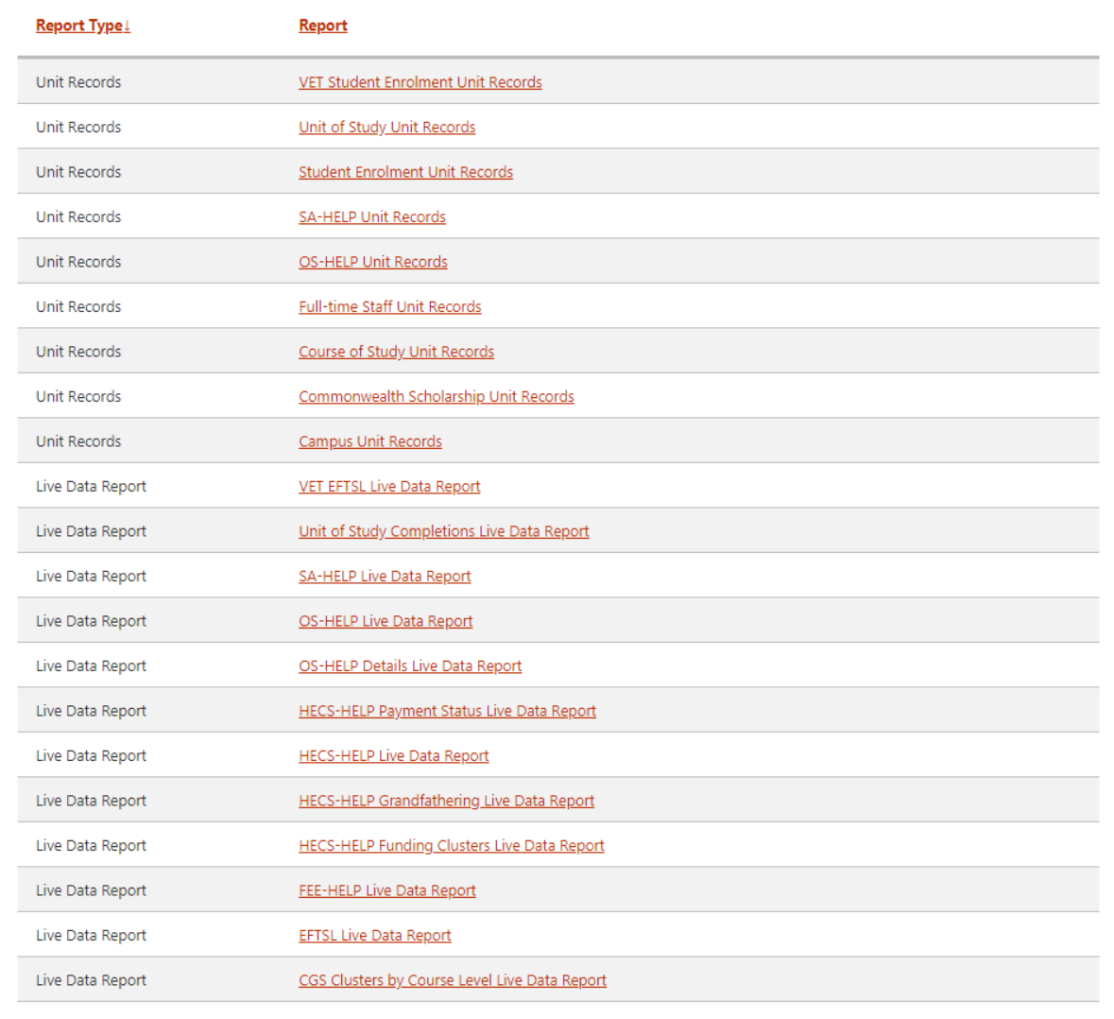

Click the name of the report to display the data within the report.

The selected report is displayed in a separate tab. For example:

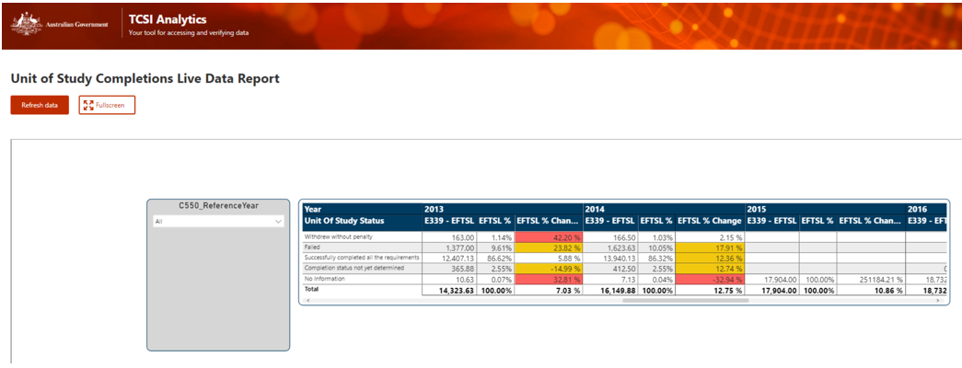

# Report

## 4.1 Report Layout



The Reports tab is laid out in the following order:

* Report identification and report functions; and
* Report area.

## 4.2 Report Identification and Report Functions



The name of the report is displayed as well as the following two report functions:

| **Function** | **Purpose** |
| --- | --- |
|  | Used to request a refresh of the data displayed in the report.  Note that this button is not operational in the first release of TCSI Analytics. |
|  | Used to display the report area in full screen mode.  Click ‘Esc’ on the keyboard to return to normal screen mode. |

## 4.3 Report Area

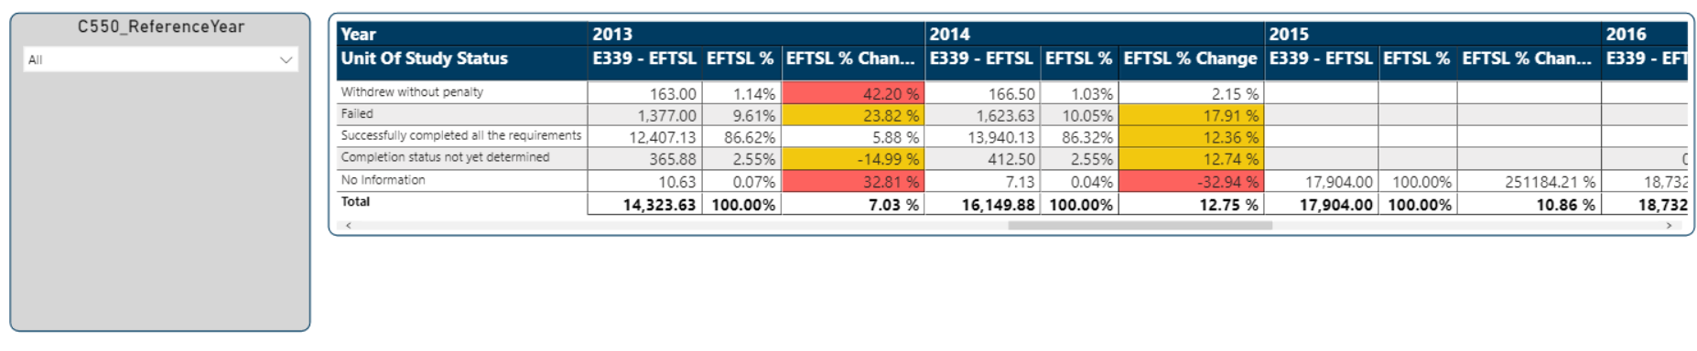

The report displayed in this area generally contains the following:

* Filters that can be used to refine the data to be displayed in the report; and
* The actual report.

### 4.3.1 Report Filters

Filters are available to narrow the data to be displayed within the report.

One or more filters can be displayed for each report. Selections within a filter are generally available as multiple selections.

Click the down arrow to display the selection available within the filter. Example:

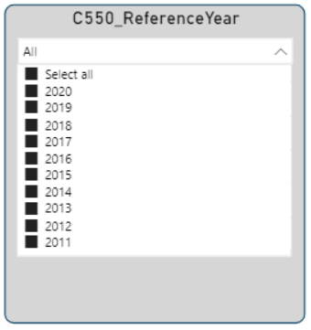

Then click the selection required.

### 4.3.2 Summary Report

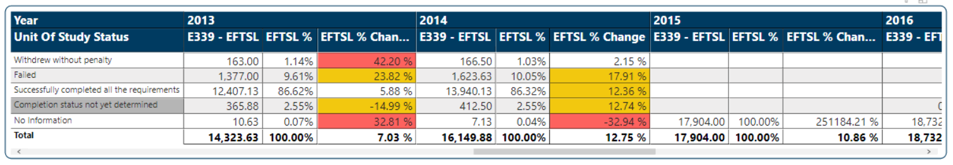

All reports with the exception of Unit Records are initially displayed as summary reports.

Drill-through reports are available to display the data that made up the count in the summary report.

To display the drill-through report:

* Right click on the count required; and
* Select ‘Drill through’; and
* Select ‘Details’.

The drill-through report is displayed. For example:

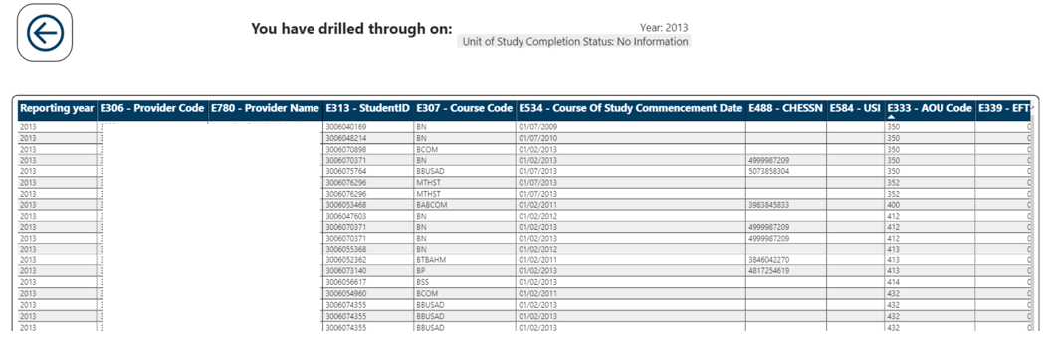

### 4.3.3 Drill-through Report Layout

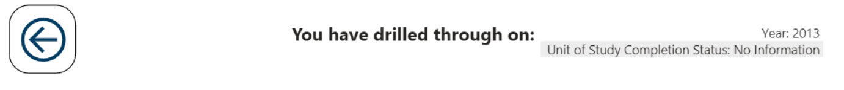

The drill-through report generally contains the following:

| **Function** | **Purpose** |
| --- | --- |
|  | Used to return to the summary report. |
|  | The filters that have been applied to generate the count on the summary report are displayed in this field. |

### 4.3.4 Exporting your reports

To export data, select the more options icon (…) to display the options available: (The options icons are displayed when

More options

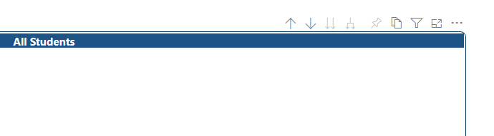

Select export data

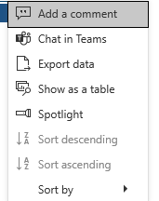



Select format and click Export.

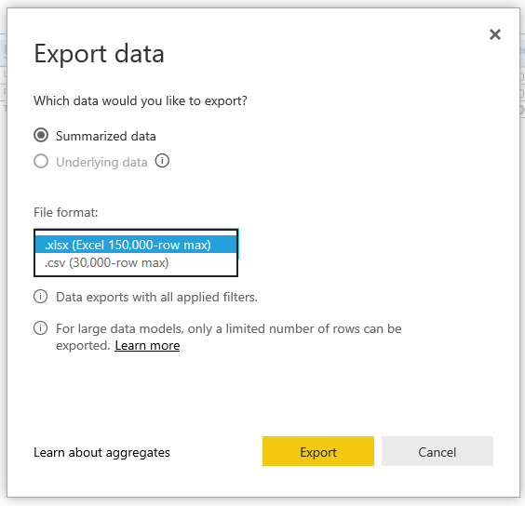

### 4.3.5 Focus Mode

Focus mode enables you to expand the selected table to full screen size. To enter Focus mode, select the Focus mode icon.

Focus mode



To exit Focus mode, click on the ‘Back to report’ tab.

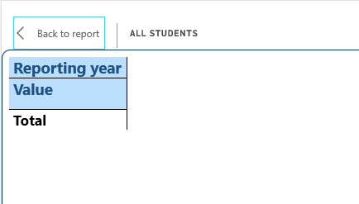

### 4.3.6 Selecting multiple items in report filter

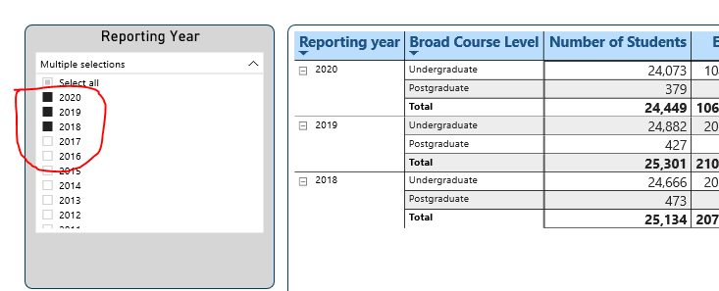

To select (or deselect) multiple items within a report filter, hold the CTRL key and click on chosen filter.

# Appendix A Report details

## 5.1 VET Student Loans reports

|  |  |
| --- | --- |
| **Report** | **Report description** |
| VET Enrolment Live Data Report | This report provides a summary of student data reported for the following categories:   * Gender * Citizenship * Indigenous Status * Level of Course * Mode of Attendance * Disability * Type of Attendance   Can be viewed by:   * Value (individual Categories) * Reporting Year |
| VET EFTSL Live Data Report | A summary of unit enrolment data reported for the following categories:   * Citizenship * Level of Course * Broad Discipline * Mode of Attendance   Can be viewed by:   * Individual Categories * Reporting Year |
| VET Student Loans Live Data Report | A summary of student loans by Broad level of course and can be viewed by:   * Reporting Year * A158 Is remitted * A159 Is Invalidated * A175 Is committed * A177 Is Adjusted |
| VET Student Enrolment Unit Records | Individual student enrolment records can be viewed by:   * E488 CHESSN * E313 Student ID * E307 Course Code * E584 USI * Reporting Year * Reporting Period |
| VET Unit of Study Unit Records | Individual student records can be accessed using the following fields:   * E488 CHESSN * E313 Student ID * E584 USI * E354 Unit of Study Code * Reporting Year * A130 Loan Status |
| VET Course Unit Records | Course data for individual courses or all courses can be viewed using these fields:   * E310 Course Of Study Type * E306 Provider Code * E307 Course Code * Reporting Year * A111 Is Deleted Course |

The table below provides a comparison between the existing report name in HEIMS Online and the report name in TCSI Analytics.

|  |  |
| --- | --- |
| **TCSI Name** | **HEIMS On-Line Name** |
| VET Student Enrolment Unit Records | Current Data Student Enrolment Report |
| VET Enrolment Live Data Report | Current Data Enrolment Summary Report |
| VET Unit of Study Unit Records | Current Data Unit of Study Report |
| VET EFTSL Live Data Report | Current Data EFTSL Summary Report |
| VET Student Loans Live Data Report | Current Data VET FEE-HELP Detailed Report |
| VET Course Unit Records | Current Data Course of Study Report |

## 5.2 Higher education reports

|  |  |
| --- | --- |
| **Report** | **Report description** |
| Enrolment Live Data Report | A summary of student enrolment data reported for the following categories:   * Gender * Citizenship * Indigenous Status * Level of Course * Tertiary Entrance Score * Special Course Type * Mode of Attendance * Broad Field of Education * Disability |
| EFTSL Live Data Report | A summary of unit enrolment load (EFTSL) reported for the following categories:   * Work Experience in Industry * Citizenship * Level of Course * Broad Discipline * Mode of Attendance * Campus Postcode * Maximum Student Contribution Indicator * Student Status |
| CGS Clusters by Course Level Live Data Report | A summary of unit enrolment data (EFTSL) reported for Commonwealth supported students by Course Level and Cluster Type. |
| HELP Live Data Report | A summary of the load (EFTSL), number of students and money amounts reported for Commonwealth Supported students by Broad Course Level. |
| FEE-HELP Live Data Report | A summary of the load (EFTSL), number of students, and money amounts reported for students accessing FEE‑HELP by Broad Course Level. |
| Adjusted FEE-HELP Live Data Report | FEE-HELP summary by reported and adjusted, HELP Debt and Loan Fee |
| HDR EFTSL Live Data Report | A summary of the load (EFTSL) and number of students reported for Research Training Programs (RTP) in Higher Degree Research courses by High/Low Cost, Citizenship, Indigenous Status and student status. |
| HDR End-user Engagement Live Data Report | Higher Degree Research students by citizenship, course of study type and scholarship type, by types of engagement |
| Commonwealth Scholarships Live Data Report | Commonwealth scholarships reported by scholarship type ([E545](https://heimshelp.education.gov.au/2018_data_requirements/2018dataelements/545)) and scholarship status (E526) for each reporting period. |
| SA-HELP Live Data Report | A summary of all SA‑HELP loans reported by Citizenship. |
| Unit of Study Completions Live Data Report | A report on the completion status ([E355](https://heimshelp.education.gov.au/2018_data_requirements/2018dataelements/355)) for each unit of study reported during the year showing the total load (EFTSL) consumed for each status |
| HECS-HELP Grandfathering Live Data Report | HECS-HELP details grouped by grandfathering provisions |
| HECS-HELP Student Split Time Series Live Data Report | HECS-HELP details grouped by liability status, grandfathering provisions, HECS Bands and Work Experience in Industry |
| HECS-HELP Payment Status Live Data Report | HECS‑HELP details grouped by contribution liable payment statuses |
| HECS-HELP Funding Clusters Live Data Report | HECS‑HELP details grouped by funding cluster and funding sub-cluster. |
| HELP Debts by Citizenships Live Data Report | HECS-HELP, FEE-HELP, OS-HELP, SA-HELP and VET Student Loans by citizenship type |
| OS-HELP Details Live Data | A summary of all OS‑HELP loans reported by OS-HELP Student Status. |
| OS-HELP ASCED General Report | A summary of OS-HELP loans reported, by   * ASCED * Country * Number of Loans * Number of Students * Total Loan Value * Total Loan Fee * Asian Flag |
| OS-HELP Country General Report | A summary of OS-HELP loans reported, by   * Country * ASCED * Number of Loans * Number of Students * Total Loan Value * Total Loan Fee * Asian Flag |
| OS-HELP Language Study General Report | A summary of OS-HELP language study loans reported, by   * Language * Number of Loans * Number of Students * Total Loan Value |
| TFN Verification Report | A list of students whose TFN could not be verified by the ATO |
| Provider Notifications Report | This report notifies providers of outstanding data issues. |
| Course Completions (HDR Students) Live Data Report | A summary of the course completions reported for Higher Degree Research students by High/Low Cost, Citizenship and Indigenous Status |
| Course Completions (All Students) Live Data Report | A summary of the course completions reported for all students by citizenship |
| Course Completions (Indigenous Students) Live Data Report | A summary of the course completions for indigenous students by course level |
| Course Completions (Special Course) Live Data Report | A summary of the course completions for students enrolled in special courses by citizenship |
| Student Enrolment Unit Records | Individual student enrolment records can be viewed by:   * E313 Student ID * E307 Course Code * E488 – CHESSN * E584 – USI * Reporting Period * Reporting Year |
| Commonwealth Scholarships Unit Records | Individual student Commonwealth Scholarship records can be viewed by:   * E313 Student ID * E488 – CHESSN * E584 – USI * Reporting Period * Reporting Year |
| OS-HELP Unit Records | Individual student OS‑HELP records can be viewed using the following fields:   * E307 Course Code * E313 Student ID * E488 – CHESSN * E584 – USI * Reporting Period * Reporting Year * Loan Status |
| SA-HELP Unit Records | Individual SA‑HELP records reported from 2012 can be viewed using the following fields:   * E313 Student ID * E488 – CHESSN * E584 – USI * Reporting Period * Reporting Year * Loan Status |
| Course of Study Unit Records | Course data for individual courses or all courses can be viewed using these fields:   * E310 Course of Study Type Code * E307 Course Code * E312 Special Course Type Code Status (Default: Not end dated) * Reporting Year * Deleted Status of Course of Study and Course |
| Student Unit of Study Unit Records | Individual student records can be accessed using the following fields:   * E313 Student ID * E488 – CHESSN * E584 – USI * E354 Unit of Study Code * Reporting Period * Reporting Year * Status (Default: Not Remitted or Invalidated or Deleted) |