

# HIGHER EDUCATION SUPPORT ACT 2003

## Notice under subsection 19-70(1)

I, Dr Andrew Taylor, Branch Manager, Market Analysis and Data Branch, Department of Education, Employment and Skills, delegate of the Minister for Education under paragraph 238-5(1)(b) of the [*Higher Education Support Act 2003*](https://www.legislation.gov.au/Series/C2004A01234)(HESA) for the purposes of subsection 19-70(2) of HESA:

Approve the form in which all 2021 data must be lodged. This is via the following submission channels:

* APIs (Application Programming Interface) for system-to-system submission; or
* File upload to the TCSI Data Entry portal.

The documents for these submission methods are available by contacting TCSI Support at [TCSIsupport@dese.gov.au](mailto:TCSIsupport@dese.gov.au)

You are required to check for any changes that may, from time to time, be made to the data requirements. All changes to the requirements for the Higher Education Data Collection will be noted in the 2021 Higher Education Data Requirements and Change Control document.

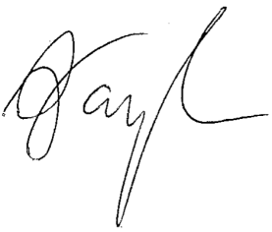

Dr Andrew Taylor

Branch Manager

Market Analysis and Data Branch

3 July 2020